


Clinique universitaire de médecine dentaire
Division de gérodontologie et prothèse adjointe

Thèse préparée sous la direction de la Professeure Frauke MÜLLER

Évaluation extra-orale de l’apparence des prothèses complètes conventionnelles et CFAO par les professionnels du domaine dentaire et les porteurs de prothèses : une enquête randomisée

Thèse
présentée à la Faculté de Médecine
de l'Université de Genève
pour obtenir le grade de Docteur en médecine dentaire
par

Charlotte Elisabeth STILWELL
née
BASTRUP-BIRCH

de
Copenhagen (Denmark)

Thèse n° 797

Genève
2022

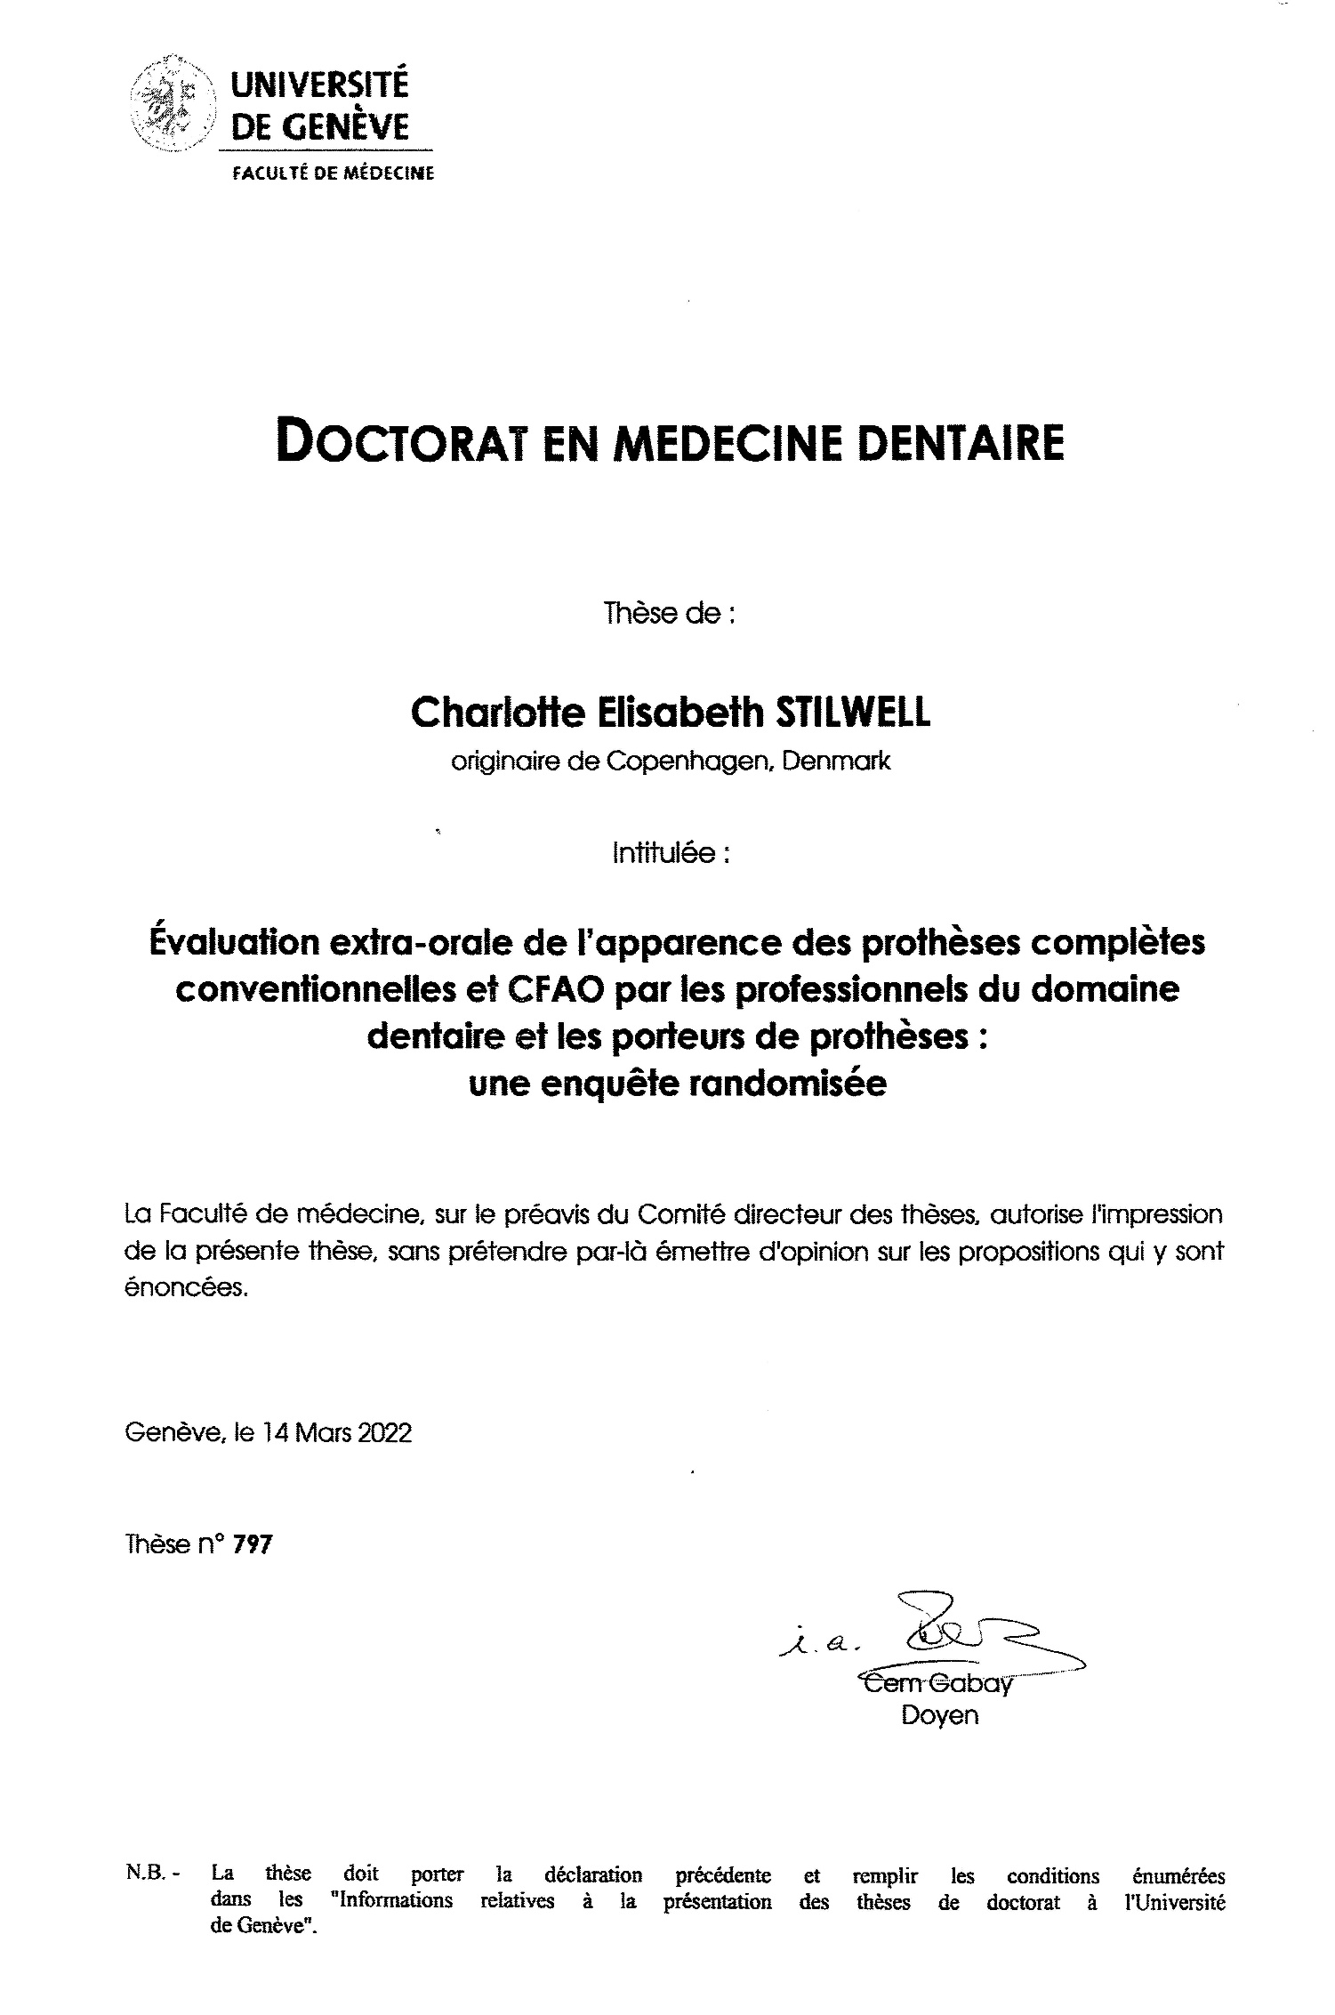

Table OF CONTENT
ACKNOWLEDGEMENTS 4
RESUME EN FRANCAIS 5
ABSTRACT IN ENGLISH 7
INTRODUCTION 8
Esthetics of complete removable dental prostheses (CRDP) 8
CRDP demographics 8
The challenges of providing successful CRDP 8
Esthetics in dentistry 9
Esthetics as a specific factor in acceptance of full dentures 11
Creating satisfactory CRDP esthetics 12
New CAD-CAM manufacturing techniques and their impact on provision of CRDP 12
New CRDP CAD-CAM manufacturing techniques and esthetics 13
REFERENCES 14
ORIGINAL MANUSCRIPT 18
ABSTRACT 18
INTRODUCTION 19
MATERIAL AND METHODS 20
Study design 20
Study sample/participants 21
Study specimens 21
Randomization of study specimens 22
Protocol 22
Statistical analysis 22
RESULTS 23
Participants 23
Reliability of method 23
Part 1: Preference of denture type 23
Ranking of the 6 CRDP types 23
Extent of preference 24
Part 2: Individual assessment of CRDPs 24
General appreciation 24
White and pink rating scores 25
Modifying factors 25
Free comments from the participants 25
DISCUSSION 26
CONCLUSIONS 29
REFERENCES 30
ACKNOWLEDGEMENTS 32
CONFLICTS OF INTERESTS AND SOURCE OF FUNDING STATEMENT 32
TABLES 33
FIGURE LEGENDS 34
DISCUSSION 39
Critique of study design 39
Advantages of study design 39
Disadvantages of study design 40
Suggestions for further exploration of denture esthetics 41
REFERENCES 42
ORIGINAL ARTICLE PUBLISHED IN JOURNAL OF DENTISTRY 43

ACKNOWLEDGEMENTS

I am very grateful to the following for their support and encouragement towards the completion of this thesis :

Professor Frauke Müller, my thesis supervisor, for the opportunity to undertake this study and submit it as a thesis. With her guidance and support it has finally been possible to include the invaluable experience of undertaking formal research in my continuing dental education. This thesis allowed us to renew and deepen our long-standing friendship.

Dr Nicole Kalberer and Dr Phillippe Mojon, for their invaluable, respective assistance with the execution of the study and statistical analyses.

Professors Martin Schimmel and Murali Srinivasan, for their constructive and meticulous criticism prior to submission of the study for publication.

My colleagues in the Division de gérodontologie et prothèse adjointe, for their friendship and inclusiveness.

Julia Gray for her constant friendship and particular encouragement in this project as well as numerous others during my dental career. Also, her daughter Corinna Gray for her assistance.

John Besford and Stephen Dover for their unwavering mentorship during my prosthodontic and implantology related professional journeys

My family, parents Åse and Charles, husband Matthew and children Thomas and Cecilia for their open-ended encouragement and understanding.

RESUME EN FRANCAIS
OBJECTIF
L'appréciation de l’apparence des prothèses dentaires complètes amovibles (Complete Removable Dental Prosthesis ‘’CRDPs’’) fabriquées par des techniques novatrices et émergentes, peut être un facteur important dans l'acceptation de la CRDP par le patient.
L'objectif de cette enquête randomisée était d'analyser la perception de l’apparence des CRDPs fabriquées par différentes techniques conventionnelles, et de conception/ fabrication assistées par ordinateurs (CFAO), par les professionnels du domaine dentaire ainsi que les personnes âgées, porteuses de prothèses dentaires.
MATERIELS ET METHODES
Quatre groupes de participants, composés des étudiants en formation prégraduée (n=10), post-graduée (n=10), de techniciens dentaires (n=10) et de personnes âgées, porteuses de CRDP (n=10), ont évalué l’apparence des spécimens de CRDP maxillaires identiques, fabriqués par six techniques différentes : 1. Bourrage de la cire perdue classique (Flask-Pack, ‘’FP’’), 2. Moulage par injection (IM), 3. Finition gingivale imitant l’apparence naturelle suivi par le moulage par injection (NG) 4. Base prothétique fraisée par CFAO avec des dents préfabriquées collées (M), 5. Base et dents fraisées par CFAO (Fully Milled, ‘’FM’’) et 6. Prototypage rapide de la base et des dents (P). Une enquête randomisée, en aveugle, comprenait 18 évaluations comparatives par paires et 12 jugements individuels des échantillons de la CRDP. Les analyses statistiques comprenaient des tests paramétriques et non paramétriques ainsi que des modèles de régression linéaire ; le niveau de signification statistique a été fixé à p<.05.
RESULTATS
NG ont été préférés le plus souvent par les groupes de professionnels, mais moins par les personnes âgées porteuses des CRDPs (p<.05). Le groupe P a obtenu les scores les plus faibles des quatre groupes de participants (p<.05). Les porteurs de CRDP ont été moins sévères dans leurs jugements et ont montré en général une plus petite marge d’évaluation. Les quatre autres groupes de CRDP (FP, IM, M et FM) ont été classés différemment selon les groupes de participants. Les trois groupes de professionnels dentaires ont mieux jugé les CRDPs ayant des dents préfabriquées aux teintes claires que ceux ayant des dents usinées, imprimées ou plus foncées. Le sexe des participants n'a pas eu d'influence sur le jugement.
CONCLUSIONS
Les résultats de cette étude ont révélé des différences marquées dans l'évaluation de l’apparence des CRDPs entre les professionnels du domaine dentaire et les porteuses de CRDP, ce qui peut être important pour l'acceptation des prothèses. Une information claire et une prise de décision participative concernant l'apparence d’une CRDP pourrait favoriser le succès du traitement.

ABSTRACT IN ENGLISH
AIM
The appreciation of the appearance of complete removable dental prostheses (CRDPs) manufactured by emerging novel manufacturing techniques, may be an important factor in patient acceptance. The aim of this randomized survey was to analyze the perception of the appearance of CRDPs manufactured by different conventional and CAD-CAM techniques by dental professionals and elder CRDP wearers.

Method and materials
Four participant groups comprised of undergraduate students (n=10), postgraduate residents (n=10), dental technicians (n=10) and elder CRDP wearers (n=10) evaluated aspects of the appearance of identical maxillary CRDP specimens, manufactured by six different techniques: 1. conventional flask-pack-press (FP), 2. injection molded (IM), 3. natural gingiva finish followed by injection molding (NG) 4. CAD-CAM milled base with bonded prefabricated teeth (M), 5. fully milled including teeth (FM) and 6. rapid-prototyped including teeth (P). A randomized, blinded survey included 18 pairwise comparative assessments and 12 individual judgements of the CRDP specimens. Statistical analyses included parametric- and nonparametric tests as well as linear regression models; the level of statistical significance was set at p<.05.

Results
NG was preferred most often by the professional groups but least by the elder CRDP wearers (p<.05). P attracted the lowest scores from all four participant groups (p<.05). CRDP wearers were less severe in their judgements and showed in general a smaller range of ratings. The other four CRDP groups (FP, IM, M, and FM) were ranked differently depending on the participant groups. The three dental professional groups judged CRDPs with prefabricated teeth better than those with milled, printed or darker shade teeth. The participants’ gender had no influence on their scoring.

Conclusions
The findings of this study revealed marked differences in the assessment of CRDP esthetics between dental professionals and elder CRDP wearers, which may be important in denture acceptance. A shared and informed approach to decision making concerning the CRDP appearance might foster the treatment success.

INTRODUCTION

Esthetics of complete removable dental prostheses (CRDP)
Esthetics of complete removable dental prostheses (CRDP) is known to be an important and potentially deciding factor in patient acceptance of a removable prostheses [1,2]. It is therefore in the professions’ interest to provide an esthetic result that the patient will find not only satisfactory but also pleasing. This requires an understanding of not only the professional aspects of producing esthetic CRDPs but also the aspects that patients deem to matter. The focus of this thesis is to explore evaluation of complete CRDP esthetics by dental professionals and non-professional CRDP wearers. A broader background to this topic is set out in the following.

CRDP demographics
Progress in prevention, restorative techniques and materials has led to an increasing proportion of people retaining their natural teeth for longer in life. In population statistics from 1980 [3], the percentage of edentulous people below the age of 44 was still as high as 14%. Today, partial and complete edentulism remain a reality [4,5] but complete tooth loss is now seen primarily in the older age groups. As an example, it is estimated that about 17% of elderly in the US over age 65 have no remaining teeth [6].
CRDP have longstanding records as both appropriate and satisfactory solutions but they have inherent functional shortcomings. Strategic use of dental implants in combination with CRDPs have been proven to significantly improve CRDP performance [7-9] but they also add to complexity and cost of treatment. Furthermore, studies have shown that the elderly patient groups are more reluctant to embark on implant therapy [10]. This is attributed to self-imposed barriers including past experiences, feeling of vulnerability and fear as well as socio-economic factors [11].
The conventional types of CRDP therefore continue to be a dental treatment reality and their inherent shortcomings continue to be a challenge for the dental profession. More than any other area of dentistry, success of CRDP depends on the extent to which the clinician can achieve patient acceptance and satisfaction.

The challenges of providing successful CRDP
Success depends on several factors. First and foremost, the CRDP needs to be fit for purpose. There are established principles for CRDP construction that seek to satisfy esthetic and functional needs, optimise patient tolerance and acceptance and minimise shortcomings [12-14]. CRDP constitutes a restoration of the physiognomy of the lower third of the face as well as a full oral rehabilitation. They also seek to restore the patient’s oral autonomy and enhance their oral health related quality of life [15]. To achieve these objectives, the construction principles address all aspects of the planned prostheses from base extensions and fit through lip support and tooth display to jaw relationship and occlusion.

The patient’s general dental and denture related history is key to a full understanding of their needs and concerns, present and past. Esthetic and functional demands are highly variable, and they are influenced by psychosocial factors, so it is essential to gain the patient’s input from the outset. The history taking should be matched by a systematic and comprehensive examination of the patient’s oral situation and any existing dentures enables the clinician to reach a diagnosis. In turn, this forms the basis for a treatment proposal aimed at obtaining informed consent and proceed with treatment based on realistic expectations.

With the aid of support and stability from the palate and alveolar ridges as well as an effective compression post dam it should be possible to achieve retention (suction) for an upper CRDP. It has been shown that patient reported satisfaction with an optimal conventional maxillary CRDP is on par with an implant retained alternative [16]. It is more difficult to achieve the same level of satisfactory outcome for CRDP in the mandible. The area available for denture support and stability is significantly less and effective retention can be elusive. Patient acceptance therefore depends significantly on their skill, tolerance and adaptability.

A diagnostic assessment can be helpful for determining scope for improvement and acceptance [17]. Additive elements of planned improvements can be tested, for example, by reversible application of plate wax to existing dentures. Additions could include testing the effect of increased base extensions, a compression post dam, enhanced lip support, enhanced tooth display and increased vertical dimension of occlusion. This approach allows the patient to assess the extent of improvement directly in their mouth and ahead of committing definitively to having treatment. If clinician and patient agree that significant improvement has been achieved, the modifications can be preserved via denture putty mould impressions or scanned. Custom copies can then be constructed from these moulds to serve as working dentures for master impressions and occlusal records.

Esthetics in dentistry
Dental esthetics in general has been gaining increasing attention and importance in recent decades. Interest is driven by the patients and fueled by the media as teeth and their contribution to overall appearance have become recognized as part of enhancing personal appearance [18]. It has also become clear that patients are willing to undergo elective and, in many cases, extensive dental treatment in the pursuit of esthetic improvement towards what they perceive as a desirable smile [19].

The concept of smile design has gained popularity as an accepted approach to improvement of dental esthetics. The concept most likely originated in an arbitrary objective of achieving an esthetic ideal of golden proportions [20] rather than a natural norm. In a more contemporary and general context, however, smile design now encompasses efforts to create harmonious, symmetrical dental arches [21,22] and the principles apply to both the arrangement of teeth as well as the architecture of the gingival tissues.

For both, conventional tooth supported as well as tooth implant-supported reconstructions, there are recognized criteria aimed at objectively judging the esthetic outcome. The aim is to achieve esthetic outcomes where the prostheses mimics natural tooth counterparts so closely as to be indistinguishable [23]. These criteria were first described for the mucosal tissues around implant reconstructions [24] and later for the tooth aspect of same as well [25]. They have become known as the pink esthetic score (PES) and white esthetic score (WES) respectively. They also serve as useful benchmarks during the planning phase for implant treatment and the terms white and pink esthetics have been adopted across dentistry as whole [26].

There are also reports in the literature on the patient’s perspective on dental esthetics. It would appear that patients’ perception of need for esthetic dental treatment to the natural dentition is greater than the professional assessment of same [27]. At the same time, there are reports that patients’ perception of the esthetics of their smile is higher than dentists’ opinions [28]. The common factor between these two reported findings is that there are likely to be differences between the patient and dentist opinions on dental esthetics.

Looking at age as a specific influencer on patient satisfaction with dental appearance, a study reported that more than 70% of the participants over the age of 50 years were dissatisfied with the color of their maxillary anterior teeth [29]. Another investigation explored esthetic preferences of a group of elder dentate patients in the event of future tooth loss [30]. Two thirds of the participants responded that they would prefer a natural age-appropriate look similar in appearance to their present dentitions if they needed tooth replacement whilst one third indicated preference for ideally formed immaculate rows of teeth.

It seems clear that in addition to differences in opinion between patients and dentists, there is also likely to be variations in preferences amongst the patients. It is therefore very important at the outset to establish the nature and extent of patients’ esthetic preferences and expectations in order to achieve acceptance and to avoid misconceptions [31].

Esthetics as a specific factor in acceptance of full dentures
Esthetics has been shown to be an important factor in acceptance of removable dentures [32-34]. In contrast to esthetics of the natural teeth, however, actual investigation into restoration of the appearance of edentulous patients has received less attention [29]. This is interesting as CRDP is a specific area of dentistry where the heightened interest in dental esthetics can be employed to its maximum potential and effect across a full range from an idealized dental smile to a more realistic, age appropriate dental appearance. Provided the full dentures also achieve general restoration of facial physiognomy and oral function, there is considerable scope for exercising freedom of preference in selection of tooth shade, mould and arrangement as well as shade, characterization, and contours of the gingival component of the denture base.
The esthetic aspect is a recognized factor in patient expectations to and acceptance of complete dentures [31-35] so it is helpful that the patient together with the dentist and the technician can offer input on the various parameters of both the white and pink esthetics.

Some dentists and technicians have turned highly customized dentures into an artform [36-38]. Whether the objective is to replicate the natural characteristics as closely and realistically as possible or to provide an idealized smile, the means for achieving customization of both the white and pink esthetic aspects exist. The esthetic quality and characterization of prefabricated denture teeth have improved remarkably as have the techniques and materials for mimicking gingival tissues. With careful attention to try-in of the set-up of teeth and soft tissue profile and contouring in the clinic together with custom finish in the dental laboratory, astonishingly lifelike prostheses can be achieved. However, the customization requires both time and skill and it is therefore likely to impact on cost and availability.

Some aspects of a highly customized denture can impact adversely on food retention and ability to remove biofilm. Imitation of gingival and interdental papilla recession together with separation between denture teeth adds significantly to realistic appearance. On the other hand, it adds to the complexity of denture cleaning. Where deliberate separation between denture teeth allows interproximal access for flossing it follows that flossing will also be required. It is worth noting that retention of, for example, parsley between natural teeth is difficult to detect without a look in the mirror. With a CRDP it will be even harder, and it will be further compounded if the CRDP wearer has reduced oral self-cleansing effect through a reduced saliva flow.

As a rule, it is therefore sensible to consider the patient’s ability to undertake appropriate denture hygiene [39]. Existing dentures may provide helpful information as would examination of dexterity and investigation of saliva flow. Where difficulties are present but a clear wish for a customized finish still exists, one solution is to cover the customized details with a clear, smooth acrylic outer finish of the denture surface.

Creating satisfactory CRDP esthetics
Established guidelines exists for setting up denture teeth for CRDP. These guidelines are derived from anatomic, esthetic and functional considerations as well as assessment of skeletal and incisal relationship [14]. The teeth in the denture specimens fabricated for this study were set up according to these guidelines and made it possible to achieve a uniform arrangement and appearance between the denture specimens.

For more detailed individuality, photographs from the patient’s dentate past can be a tremendous help towards recognising the original anterior tooth relationship, arrangement and characteristics [40]. Details of the original tooth positions to be imitated or avoided can thereby be discussed and agreed. Photographs can also be used to calculate the width of the natural central incisors [41]. To do so, the photograph must show the patient face on with the pupils in both eyes and the two upper central incisors clearly visible. The inter-pupillary distance, which does not change after the age of 10 years, can then be measured in real life as well as on the photo and used for the ratio comparison between the photograph and patient [38].

An essential step in achieving a satisfactory esthetic result is to seek the patient’s input. The interrelationship between physiognomy and esthetics means that this input should be both by feel and by appearance. For the latter, a mirror for the patient’s use is a sine quo none but modern digital means can also be employed. A video recording of the patient from different angles and with the face at rest as well as actively engaged in speech, smile and laughter provides the patient with an opportunity to evaluate themselves in the same more holistic manner as the dental team.

New CAD-CAM manufacturing techniques and their impact on provision of CRDP
The CAD-CAM manufacturing techniques for full dentures have steadily been gaining popularity. Clinically acceptable results are reported for both of the two principal techniques, rapid prototype 3D printing (RP) and subtractive milling [42,43]. Comparison between complete dentures manufactured by CAD-CAM milling and complete dentures constructed with conventional techniques, demonstrate similar or better fit of the intaglio surfaces, equal biocompatibility, and improved mechanical properties [44-51]. Patient satisfaction with RP fabricated complete dentures is also reported to be similar to conventional complete dentures [52].

Advantages and disadvantages of both techniques are listed in the following :
Milling | 3D printing
Pre-polymerization under high pressure thus minimizing porosities | No waste of material
Disadvantages: | Can be done in the dental practice
Difficult to incorporate with teeth or even layered whites (stratification) | Printer at (relatively) low cost
Important financial investment for the milling machine | Precision independent of the size of the milling instrument
Logistic problems, as denture has to be sent to a milling center | Easier to produce pieces in different colors
Plastic pollution of the environment during milling | Disadvantages:
 | Exposition to liquid monomer during fabrication process

New CRDP CAD-CAM manufacturing techniques and esthetics
Whereas satisfactory comfort and function has been documented for CAD-CAM manufactured dentures, no study to date appears to have addressed evaluation of their esthetic aspects. It is possible to manufacture a milled denture base and then add prefabricated denture teeth to this, thereby benefitting from their esthetic quality and characterization. By contrast, it is today not possible to incorporate the same degree of detail when the teeth are milled or rapid prototype printed as a part of a complete CAD-CAM manufacturing process. At this point in the evolution of these CAD-CAM processes, the esthetic quality of the printed version in particular is very inferior to the prefabricated alternative.
With the prospect that CAD-CAM manufactured CRDP will become increasingly routine together with an increasing emphasis on a patient centred approach and reported outcomes (PROMs) [51], it seemed logical to explore the potential differences between esthetic opinions of CRDP wearers and dental professionals of CRDP manufactured by different conventional and CAD-CAM techniques.

REFERENCES
[1] D.A. Garber, M.A. Salama. The aesthetic smile: diagnosis and treatment. Periodontol 2000. 11 (1996) 18-28.
[2] C.R. Marachlioglou, J.F. Dos Santos, V.P. Cunha, L. Marchini, Expectations and final evaluation of complete dentures by patients, dentist and dental technician. J Oral Rehabil 37 (2010) 518-24.
[3] J.G. Steele, E. Treasure, N.B. Pitts, J. Morris, G. Bradnock, Total tooth loss in the United Kingdom in 1998 and implications for the future. Br Dent J 189(11) (2000) 598-603.
[4] P. Mojon, The world without teeth: Demographic Trends. In: Implant Overdentures, the Standard of Care for Edentulous Patients. Eds J. Feine and G. E. Carlsson. Chicago, Quintessenz (2003)3-14.
[5] F. Müller, M. Naharro, G.E. Carlsson, What are the prevalence and incidence of tooth loss in the adult and elderly population in Europe? Clin Oral Implants Res 18 Suppl 3 (2007) 2-14.
[6] Centers for Disease Control and Prevention, Oral Health Surveillance Report: Trends in Dental Caries and Sealants, Tooth Retention, and Edentulism, United States, 1999–2004 to 2011–2016. Atlanta, GA: Centers for Disease Control and Prevention, US Dept of Health and Human Services; (2019).
[7] J.S. Feine, G.E. Carlsson, M.A. Awad, A. Chehade, W.J. Duncan, S. Gizani, T. Head, G. Heydecke, J.P. Lund, M. MacEntee, R. Mericske-Stern, P. Mojon, J.A. Morais, I. Naert, A.G. Payne, J. Penrod, G.T. Stoker, A. Tawse-Smith, T.D. Taylor, J.M. Thomason, W.M. Thomson, D. Wismeijer, The McGill consensus statement on overdentures. Mandibular two-implant overdentures as first choice standard of care for edentulous patients. Gerodontology 19(1) (2002) 3-4.
[8] J.M. Thomason, S.A. Kelly, A. Bendkowski, J.S. Ellis, Two implant retained overdentures--a review of the literature supporting the McGill and York consensus statements. J Dent 40(1) (2012) 22-34.
[9] N. Kodama, B.P. Singh, D. Cerutti-Kopplin, J. Feine, E. Emami, Efficacy of Mandibular 2-implant Overdenture: An Updated Meta-analysis on Patient-based Outcomes. JDR Clin Trans Res 1(1) (2016) 20-30.
[10] J.S. Ellis, A. Levine, C. Bedos, P. Mojon, Z. Rosberger, J. Feine, J.M. Thomason, Refusal of implant supported mandibular overdentures by elderly patients. Gerodontology 28(1) (2011) 62-8.
[11] F. Müller, K. Salem, C. Barbezat, F.R. Herrmann, M. Schimmel, Knowledge and attitude of elderly persons towards dental implants. Gerodontology 29(2) (2012) e914-23.
[12] J.F. McCord, A.A. Grant. Impression making. Br Dent J 188(9) (2000) 484-92.
[13] F. Fayz, A. Eslami, Determination of occlusal vertical dimension: a literature review. J Prosthet Dent 59(3) (1988) 321-3.
[14] J. Ehrlich, E. Gazit, Relationship of the maxillary central incisors and canines to the incisive papilla. J Oral Rehabil 2(3) (1975) 309-12.
[15] J.S. Ellis, N.D. Pelekis, J.M. Thomason, Conventional rehabilitation of edentulous patients: the impact on oral health-related quality of life and patient satisfaction. J Prosthodont 16(1) (2007) 37-42.
[16] J.M. Thomason, G. Heydecke, J.S. Feine, J.S. Ellis, How do patients perceive the benefit of reconstructive dentistry with regard to oral health-related quality of life and patient satisfaction?. Clin. Oral Impl. Res 18 (Suppl. 3) (2007) 168–88.
[17] C. Stilwell, Risk management in clinical practice. Part 6b. Identifying and avoiding medico-legal risks in removable dentures. Br Dent J 209(7) (2010) 339-50.
[18] C.J. Mehl, S. Harder, S. Wolfart, O. Vollrath, A. Trinkler, H.J. Wenz, M. Kern, Influence of dental education on esthetic perception. Int J Esthet Dent 10(3) (2015) 486-99.
[19] Z.Z. Akarslan, B. Sadik, H. Erten, E. Karabulut, Dental esthetic satisfaction, received and desired dental treatments for improvement of esthetics. Indian J Dent Res 20(2) (2009) 195-200.
[20] E.I .Levin, Dental esthetics and the golden proportion. J Prosthet Dent 40(3) (1978) 244-52.
[21] N.C. Davis, Smile design. Dent Clin North Am 51(2) (2007) 299-318.
[22] M. Bhuvaneswaran, Principles of smile design. J Conserv Dent 13(4) (2010) 225-32.
[23] F. Higginbottom, U.C. Belser, J.D. Jones, S.E. Keith, Prosthetic management of implants in the esthetic zone. Int J Oral Maxillofac Implants 19 Suppl (2004) 62-72.
[24] R. Fürhauser, D. Florescu, T. Benesch, R. Haas, G. Mailath, G. Watzek, Evaluation of soft tissue around single-tooth implant crowns: the pink esthetic score. Clin Oral Implants Res 16(6) (2005) 639-44.
[25] U.C. Belser, L. Grütter, F. Vailati, M.M. Bornstein, H.P. Weber, D. Buser, Outcome evaluation of early placed maxillary anterior single-tooth implants using objective esthetic criteria: a cross-sectional, retrospective study in 45 patients with a 2- to 4-year follow-up using pink and white esthetic scores. J Periodontol 80(1) (2009) 140-51.
[26] A. Lanza, F. Di Francesco, G. De Marco, F. Femiano, A. Itro, Clinical Application of the PES/WES Index on Natural Teeth: Case Report and Literature Review. Case Rep Dent (2017) 9659062.
[27] D. Tortopidis, A. Hatzikyriakos, M. Kokoti, G. Menexes, N. Tsiggos. Evaluation of the relationship between subjects' perception and professional assessment of esthetic treatment needs. J Esthet Restor Dent 19(3) (2007) 154-62.
[28] J. Jornung, O. Fardal, Perceptions of patients' smiles: a comparison of patients' and dentists' opinions. J Am Dent Assoc 138(12) (2007) 1544-53.
[29] V. Lajnert, D.K. Pavičić, R. Gržić, Z. Kovač, D. Pahor, D. Kuis, S. Simonić-Kocijan, R. Antonić, D. Bakarčić, Influences of age and maxillary anterior teeth status on patient's satisfaction with dental appearance and tooth colour. Gerodontology 29(2) (2012) e674-9.
[30] R. Hartmann, F. Müller, Clinical studies son the appearance of natural anterior teeth in young and old adults. Gerodontology 21 (2004) 10-6.
[31] M. Waliszewski, Restoring dentate appearance: a literature review for modern complete denture esthetics. J Prosthet Dent 93 (2005) 386-94.
[32] C.R. Marachlioglou, J.F. Dos Santos, V.P. Cunha, L. Marchini, Expectations and final evaluation of complete dentures by patients, dentist and dental technician. J Oral Rehabil 37 (2010) 518-24.
[33] M.G. Gaspar, M.B. Dos Santos, J.F. Dos Santos, L. Marchini, Correlation of previous experience, patient expectation and the number of post-delivery adjustments of complete dentures with patient satisfaction in a Brazilian population. J Oral Rehabil 40 (2013) 590-4.
[34] M. McCunniff, W. Liu, D. Dawson, L. Marchini, Patients' esthetic expectations and satisfaction with complete dentures. J Prosthet Dent 118 (2017) 159-65.
[35] G.E. Carlsson, A. Otterland, A. Wennstrom, Patient factors in appreciation of complete dentures. J Prosthet Dent 17 (1967) 322-8.
[36] J.N. Besford, A.F. Sutton, Aesthetic possibilities in removable prosthodontics. Part 1: the aesthetic spectrum from perfect to personal. Br Dent J 224 (2018) 15-9.
[37] J.N. Besford, A.F. Sutton, Aesthetic possibilities in removable prosthodontics. Part 2: start with the face not the teeth when rehearsing lip support and tooth positions. Br Dent J 224(3) (2018) 141-48.
[38] J.N. Besford, A.F. Sutton, Aesthetic possibilities in removable prosthodontics. Part 3: Photometric tooth selection, tooth setting, try-in, fitting, reviewing and trouble-shooting. Br Dent J 224 (2018) 491-506.
[39] A. Peracini, I.M. Andrade, F. Paranhos Hde, C.H. Silva, R.F. de Souza. Behaviors and hygiene habits of complete denture wearers. Braz Dent J 21(3) (2010) 247-52.
[40] M. Fradeani, G. Barducci, Esthetic Rehabilitation In Fixed Prosthodontics: Vol 2. Quintessenz, Berlin, (2008)
[41] P.J. Wehner, J.C. Hickey, C.O. Boucher. Selection of artificial teeth. J Prosthet Dent 18 (1967) 222-32.
[42] A.S. Bidra, K. Farrell, D. Burnham, A. Dhingra, T.D. Taylor, C.L. Kuo, Prospective cohort pilot study of 2-visit CAD/CAM monolithic complete dentures and implant-retained overdentures: Clinical and patient-centered outcomes. J Prosthet Dent 115 (2016) 578-86.
[43] M.T. Kattadiyil, R. Jekki, C.J. Goodacre, N.Z. Baba, Comparison of treatment outcomes in digital and conventional complete removable dental prosthesis fabrications in a predoctoral setting. J Prosthet Dent 114 (2015) 818-25.
[44] B.J. Goodacre, C.J. Goodacre, N.Z. Baba, M.T. Kattadiyil, Comparison of denture base adaptation between CAD-CAM and conventional fabrication techniques. J Prosthet Dent 116 (2016) 249-56.
[45] M. Srinivasan, Y. Cantin, A. Mehl, H. Gjengedal, F. Müller, M. Schimmel, CAD/CAM milled removable complete dentures: an in vitro evaluation of trueness Clin Oral Investig 21 (2017) 2007-19.
[46] P.A. Steinmassl, V. Wiedemair, C. Huck, F. Klaunzer, O. Steinmassl, I. Grunert, H. Dumfahrt, Do CAD/CAM dentures really release less monomer than conventional dentures? Clin Oral Investig 21(5) (2017) 1697-705.
[47] M. Srinivasan, H. Gjengedal, M. Cattani-Lorente, M. Moussa, S. Durual, M. Schimmel, F. Müller, CAD/CAM milled complete removable dental prostheses: An in vitro evaluation of biocompatibility, mechanical properties, and surface roughness. Dent Mater J 37(4) (2018) 526-33.
[48] O. Steinmassl, H. Dumfahrt, I. Grunert, P.A. Steinmassl, CAD/CAM produces dentures with improved fit. Clin Oral Investig 22(8) (2018) 2829-35.
[49] N. Kalberer, A. Mehl, M. Schimmel, F. Müller, S. Srinivasan, CAD-CAM milled versus rapidly prototyped (3D-printed) complete dentures: an in vitro evaluation of trueness. J Prosthet Dent 121(4) (2019) 637-43.
[50] M. Srinivasan, N. Kalberer, M. Naharro, L. Marchand, H. Lee, F. Müller, CAD-CAM milled dentures: The Geneva protocols for digital dentures J Prosthet Dent 123 (2020) 27–37.
[51] P.C. Saponaro, B. Yilmaz, W. Johnston, R.H. Heshmati, E.A. McGlumphy, Evaluation of patient experience and satisfaction with CAD-CAM-fabricated complete dentures: A retrospective survey study. J Prosthet Dent 116 (2016) 524-8.
[52] J. Feine, S. Abou-Ayash, M. Al Mardini, R.B. de Santana, T. Bjelke-Holtermann, M.M. Bornstein et al. Group 3 ITI Consensus Report: Patient-reported outcome measures associated with implant dentistry. Clin Oral Implants Res 29(Suppl 16) (2018) 270-5.

ORIGINAL MANUSCRIPT

ABSTRACT
Introduction complete removable dental prostheses’ (CRDPs) appearance may vary between conventional and contemporary CAD-CAM manufacturing techniques.

OBJECTIVES
The aim of this randomized survey was to analyze appreciation of CRDPs manufactured by different techniques by dental professionals and elder CRDP wearers.

METHODS
Four participant groups comprised of undergraduate students (n=10), postgraduate residents (n=10), dental technicians (n=10) and elder CRDP wearers (n=10) evaluated appearance of maxillary CRDP specimens manufactured by six different techniques: three conventional 1. flask-pack-press (FP), 2. Injection-molded (IM), 3. intrinsically colored natural gingiva finish before injection-molded (NG) and three CAD-CAM 4. milled base with bonded prefabricated teeth (M), 5. fully milled including milled teeth (FM) and 6. rapid-prototyped including printed teeth (P). A randomized, blinded survey included 18 pairwise comparative assessments and 12 individual judgements of the CRDP specimens on general appearance as well as pink and white aspects. Statistical analyses included parametric- and nonparametric tests as well as linear regression models; the level of statistical significance was set at p<.05.

RESULTS
NG was preferred by the professional groups but not by the elder CRDP wearers (p<.05). P was scored lowest by all four participant groups (p<.05). CRDP wearers’ ratings were less severe and within a narrower range. The ratings of the two CAD-CAM milled CRDPs (M, and FM) were ranked closer to (FP, IM) and the order of preference was different depending on the participant groups.

CONCLUSIONS
The findings of this study revealed marked differences in the assessment of CRDP appearances between dental professionals and older CRDP wearers.

CLINICAL SIGNIFICANCE
A shared and informed approach to decision making concerning the CRDP appearance might foster denture acceptance and treatment success.

INTRODUCTION
Dental esthetics has been gaining increasing attention and importance in the recent decades. Interest is driven by the patients and fueled by the media as teeth and their contribution to overall appearance have become recognized as part of enhancing personal appearance [1]. The greater focus on dental esthetics has therefore infiltrated the various dental disciplines as dentists look to address the current day esthetic expectations [1, 2].
Complete removable dental prostheses (CRDPs) are a specific area of dentistry where this heightened interest in dental esthetics can be employed to its maximum potential and effect [3]. The esthetic aspect is a recognized factor in patient expectations to and acceptance of CRDPs [4-7], so it is helpful to offer input on the various parameters of CRDP esthetics. Restoration of the appearance of edentulous patients has received limited attention [8, 9], although the psychological burden and functional impairment of tooth loss may vary between patients, there is general agreement that they are important [10, 11]. Therefore, some dentists and technicians have turned highly customized dentures into an artform [9]. Whether the objective is to replicate the natural characteristics as closely and realistically as possible or to provide an idealized smile, the means for achieving both the white and pink esthetic aspects exist. The esthetic quality and characterization of prefabricated denture teeth have improved remarkably as have the techniques and materials for mimicking gingival tissues. With careful attention to try-in of the set-up of teeth and soft tissue profile and contouring in the clinic together with custom finish in the dental laboratory, astonishingly lifelike prostheses can be achieved. The aim of a natural and age-appropriate appearance is to allow the edentulous person to keep the fact that they are wearing a removable prosthesis private. This is often referred to as “prosthetic or dental privacy” [12]. Customization of dentures requires both time and skill and is likely to impact on cost and availability. In the findings of a qualitative study, there is support for suggesting that customization would also be appreciated by the patients [13].
Comparing professional and patients’ perception of need for esthetic dental treatment to the natural dentition, the literature suggests that patients judge the need to be higher than the dental professional [2]. However, there are also reports that patients’ perception of the esthetics of their smile is higher than dentists’ opinions [14, 15]. The common factor between these reported findings is that there are likely to be differences between the patient and dentist opinions on dental esthetics. The initial evaluation of the patient’s preferences and expectations may foster the acceptance of the treatment outcome [8, 16].
The CAD-CAM manufacturing techniques for CRDPs have steadily been gaining popularity. Clinically acceptable results are reported for both of the two principal techniques, the subtractive milling [17, 18] and the more recently additive rapid prototyped (RP) also known as 3D printing [19, 20]. Comparison between CRDPs manufactured by CAD-CAM milling and those constructed with conventional techniques, demonstrate similar or better fit of the intaglio surfaces, equal biocompatibility, and improved mechanical properties [21-23]. Patient satisfaction with CAD-CAM fabricated CRDPs is also reported to be similar to conventional CRDPs [24].
Whereas satisfactory comfort and function has been documented for CAD-CAM manufactured CRDPs, to the knowledge of the authors, no study to date has addressed appreciation of their overall appearance or distinguished between their white and pink aspects. With appearance as an important factor in patient acceptance of CRDPs and in particular of the maxillary denture [4, 5, 7], evaluation of this aspect of the CAD-CAM types is therefore both important and relevant as is their comparison to conventional CRDPs.
With the potential differences between opinions of patients and dental professionals and the increasing emphasis on inclusion of patient-reported outcomes measures [25], it is also logical to explore opinions of both groups.
Therefore, the aim of this study was to evaluate and analyze the opinions of dental professional groups and elder denture wearers regarding appearance of CRDPs fabricated by six different manufacturing techniques.

MATERIAL AND METHODS
This non-interventional, quality control randomized survey did not require the ethics approval from the ethics committee as it did not involve any patients, patient-related data or biological samples.

Study design
The study was divided into Part 1, a pairwise comparative assessment and Part 2, where CRDPs were rated individually (Table 1).
In Part 1, the participants were given a set of 12 CRDP specimens and asked to make a total of 18 comparisons based on pre-determined randomized pairings. The first 15 pairings ensured a comparison of each of the six CRDP types against the other five. For reliability of method, the remaining three were mock trial comparisons of identical FP, NG and FM (Fig. 2). The participants were asked to indicate their preference towards one denture or the other for each of six questions using a horizontal visual analogue scale (VAS) regarding six criteria: 1) general appearance of CRDP teeth, 2) shade of CRDP teeth, 3) detail of CRDP gingiva, 4) shade of gingiva, 5) design of palate, and 6) overall/global CRDP preference.

The midpoint of the 10 cm long VAS scales line served as a point of no preference and accordingly an allocated score from -5 to 5 indicated which side CDRP was preferred and to what extent. The measurement was recorded at the nearest millimeter. Participants had the opportunity to provide comments. All the study participants made the same 18 comparisons, but in a different randomized order.
In Part 2 of the study, the participants were asked to rate individually the 12 CRDPs; two for each manufacturing group. The questionnaire used a numerical scale from 1 (lowest) to 10 (highest) scores for a total of 10 parameters. Of those, five related to the white esthetics of the CRDP teeth (shape, natural appearance, surface detail, contours, shade/transparency) and five related to the pink esthetics of the gingiva imitation in the CRDP bases (shape, natural appearance, detail, transition to teeth, shade).

Study sample/participants
The study recruited 40 participants in four groups, 1- undergraduate students (UG) 2- postgraduate residents in a prosthodontic specialization program (PG), 3- dental technicians (DT) and 4- elder CRDP wearers (DW). There were no further inclusion criteria for UG, PG and DT groups. For the DW group, participants were only included if they were non-dental persons, aged 70 years or older, and were rehabilitated with a maxillary CRDP.

Study specimens
To allow more than one study participant participating at a time, a total of sixty maxillary CRDP specimens were fabricated from a single master model with an ideal set-up of teeth. The CRDPs were produced in sets of ten using six different manufacturing techniques: 1- conventional flask-pack-press (FP) using heat-polymerizing resin (Ivoclar ProBase, Ivoclar Vivadent AG, Schaan Lichtenstein), 2- injection molding (IM) using the IvocapTM technique (Ivoclar Vivadent AG) with a modified polymethylmethacrylate (PMMA) resin (Ivobase High Impact, Ivoclar Vivadent AG) 3- customized finish with a multi-colored nature mimicking gingiva (NG) with a shading by a salt and vinegar technique for addition of color tones tone tints (Schottlander Enigma Color Tones, Schottlander, Letchworth, UK) prior to finishing of the remainder of the NG denture in heat cured resin (Ivobase pink veined resin, Ivoclar Vivadent AG) by an injection moulding process, 4- milled based with bonded teeth (M) (AVADENT™, GDS, Global Dental Science Europe BV, Tilburg, The Netherlands), 5- CAD/CAM fully milled including milled teeth (FM) (AVADENT™) and 6- rapid-prototyped (P) (NextDent B.V., Soesterberg, Netherlands) (Fig 1.). The artificial denture teeth used in the CRDP groups (FP, IM, NG and M) were identical: anterior teeth mold - PhysioStar NFC+ mold 664 and posterior teeth mold - Bonartic II NFC+ mold 04 (both Candulor AG, Glattpark, Switzerland).
The shades of the teeth in IM, NG and M was A3, and A4 color was selected for the FP group. The teeth mold used in the FM and P groups were identical and their shade was A3. The custom finish of the gingival aspect in NG included detailed contouring and intrinsic staining shading for imitation of the characteristics and appearance of natural gingival tissues. The gingival aspect of FP and IM were hand finished following a standard approach.

Randomization of study specimens
Six blocks of 10 random numbers each were generated for the 6 CRDP groups by an online randomizing software (www.randomizer.org). The CRDP specimens were labelled accordingly with a unique number via an adhesive sticker, and the allocation was concealed and blinded to the participants. Next, five sets of 12 CRDP study specimens were collated, comprising a pair of specimens from each of the six CRDP groups. These five sets of 12 CRDP study specimens were used an equal number of times each across the four participant groups UG, PG, DT and DW.

Protocol
Ten participants were recruited for each of the four study groups. The recruitment of participants and completion of the questionnaires was organized and supervised by a single investigator (NK) in groups of no more than 5 participants. First the participants received detailed information about the experiments, studied the questionnaires and had their questions clarified. A training sheet for the use of the VAS scale was administered, where participants marked 25%, 80%, 10%, 45% and 75% of the scale. Then, each study participant received a pre-prepared set of 12 CRDPs. Participants and supervisor were blinded to the manufacturing techniques of the specimens. A total of 40 questionnaires, each with 18 comparisons of CRDP pairs and 12 judgements of individual CRDPs were completed. The outcome parameters are listed in Table 1.

Statistical analysis
The comparisons in the five appearance questions (Q1, Q2, Q3, Q4 and Q6) in Part 1 were analyzed as both, absolute preference of one CRDP type over the others (Q6), and extent of preference as indicated on the VAS of a given type over each of the other 5 CRDP types. For the latter, the average value of the 5 VAS comparisons for each question was analyzed.
Concerning Part 2, for each question, the average of the ratings of the 2 CRDPs of the same type for each of the 10 questions were calculated. White (Q1-Q5) and pink (Q6-Q10) rating scores were obtained by averaging the answers to Q1-Q5 and Q6-Q10, respectively. The overall rating for each CRDP was analyzed as the average for the Q1-Q10 scores.
For Part 1, the distribution of the extent of preference scores did not follow a normal distribution according to a Kolmogorov-Smirnov test. All comparisons were performed using a Kruskal-Wallis test followed by the Dunn-Bonferroni adjusted post-hoc test, to show homogenous subset based on rank.
Answers to VAS questions of Part 2 were normally distributed. The influence of CRDP types, gender, and groups, on the ratings were analyzed using a linear regression model. Difference between CRDP types and groups were further analyzed using the Tukey pairwise comparison post-hoc test. Violation of homogeneity of variance was tested according to Levene’s test. Correlation coefficient were computed using Spearman Rho coefficient for Part 1 and Pearson coefficient for Part 2.
The significance level was set at p<.05. Statistical analysis was performed by a biostatistician (PM) using a statistical software (SPSS version 25.0, IBM Corporation).

RESULTS

Participants
Forty participants distributed into four groups (UG age=25.1±4.6 years; PG age=32.7±2.7 years, DT age=51.8±11.6 years; DW age 75.3±4.0 years) participated in this survey. The number of men and women was equal in each group, except for DT where 8 men and 2 women participated.

Reliability of method
The accuracy of marking specific values on a 10 cm visual analogue scale (25%, 80%, 10%, 45% and 75%) was high (interquartile range (IQR) 0.5 cm). The dental technicians and CRDP wearers were significantly less precise than the postgraduate and undergraduate students (Kruskall-Wallis p<.05), the maximum median difference was 0.1 cm (IQR 0.6).
In the mock trial comparisons of two identical CRDP types (FP, NG and FM), the recorded scores were consistently close to the reference midpoint of the VAS scales (median 0.04 cm, interquartile range 0.05 cm) but outliers occurred in all groups of up to 0.48 cm. Gender of the participant and type of CRDP did not influence the results of the mock trial. The only difference was detected in DW who were significantly less accurate (Kruskall-Wallis p<.01) with a maximum median difference of 0.1 cm.

Part 1: Preference of denture type

Ranking of the 6 CRDP types
In undergraduate students and postgraduate residents as well as dental technicians, the CRDP that was the most often globally preferred over the others was NG (Q6). In contrast, the DW ranked NG last (p<.05). Preference for P occurred only in the DW group and was never preferred against any other CRDP type by any of the other groups (Table 2).

Extent of preference
As for the extent of the global preference (Q6), P was the least preferred, followed by FP and FM (Fig. 3). There was no difference in the extent of preference between IM, M and NG, which were the most preferred CRDPs (Kruskall-Wallis p<.01). These CRDP types were those that had pre-fabricated teeth in color A3. For dental technicians, the FM was equivalent to the 3 best rated CRDPs. However, for CRDP wearers, P and NG were similarly disliked while there was no clear preference given to any of the 4 other CRDPs.
Analysis of the general appearance of the teeth (Q1) and the finish of the gingiva (Q3) preference scores indicated a similar trend to the global (Q6) score with Rho correlation coefficients of 0.78 and 0.84, respectively (Fig. 4, 5). The correlation between Q1 and Q3 was lower (rho 0.64) but still significant (all p<.01).
For the extent of general tooth appearance preference, P obtained the lowest score (Kruskall-Wallis p<.01), with the CRDP wearers being the least severe in their judgement (Fig. 4). There were no significant differences between IM, NG, M, FM and FP. For tooth color (Q2), P was evaluated the worst (p<.05) and the prefabricated teeth in shade A3 of IM, NG and M the best (n.s.). For CRDP wearers, the tooth appearance of IM, M and FM were similarly preferred, whilst NG and P were the least preferred.
The gingiva finish scores (Q3) were ranked in the following sequence NG, M, IM, FM, FP and as the lowest preference P (Fig. 5). Of these, only M and IM were not statistically different from each other. The color of the gingiva (Q4) was evaluated as follows: best rated IM and NG (n.s.), followed by M (p<.05); FM and FP were similarly considered as the second worst, while P obtained the worst evaluation (p<.05). For the gingiva finish, undergraduates evaluated from best to worst: NG, then IM and M similarly and finally FM, FP and P (p<.05). Postgraduates evaluated also NG as the best in gingiva finish while FP, FM, and P were similarly the lowest (p<.05). Dental technicians agreed with postgraduates for these two evaluations. For CRDP wearers, there was no statistical difference in preference of the gingiva finish for any of the CRDP types. NG showed the largest range of scores both within participant groups and between them (Fig. 4, 5).

Part 2: Individual assessment of CRDPs

General appreciation
For the general appreciation (mean of Q1-Q10), NG received the highest rating whereas P had the lowest scores. However, NG ratings were not statistically significantly different from IM and M (Fig. 6). Again, the three CRDP types with pre-fabricated light shade teeth were ranked best. The ratings for FP and FM were similar but significantly lower (p<.01) than obtained for M. Undergraduates and postgraduates ranked similarly with P the lowest and IM and NG the best (ANOVA p<.01).
For dental technicians P was rated significantly worse, but all the other CRDPs were rated similar (ANOVA p<.01).
CRDP wearers rated P as the worst, although they were less severe in their judgement than the dental professionals. P was followed by NG, FP, M, IM, FM but the differences between these 5 CRDP types were not significant. The range of their ratings was smaller than the one of dental professionals.
White and pink rating scores
Generally, the white (Q1-Q5) and pink (Q6-Q10) rating scores were confirming the overall ratings (Fig. 7, 8). The Pearson’s correlation coefficient between the white and pink rating scores was .671 (p<.001). This value was high enough to consider the two scores similar, but not redundant.
For the white rating score, in all groups of participants, P was rated significantly worse than all the other CRDPs (p<.01). All participant groups pooled, the ranking of the CRDPs according to the white rating score was, from best to worst, NG, IM, M, FM, FP, P (Fig. 7). This ranking was also found with the pink rating scores but here P was not different from the next two worst ratings FP and FM (Fig. 8).
Undergraduates, postgraduates, and dental technicians agreed on this ranking for white and pink rating score (ANOVA p<.01). CRDP wearers provided a different ranking for white rating score: from best to worst FM, IM, M, FP, NG, P (p<.01). Yet they rated all the CRDPs similar for the pink rating score. NG obtained the most widespread range of ratings both within participant groups and between.

Modifying factors
According to the general linear regression model, gender of the participants had no significant effect on the ratings of the CRDPs in Part 2, while the factors “CRDP type” and “participant group” were highly significant (p<.01).

Free comments from the participants
Nine participants made entries in the free comment boxes. Four commented on recognizing identical CRDPs in the mock trials. Two participants mentioned their preference might change dependent on the patient’s age and whether they were smokers or not. Two comments referred to the difficulties of cleaning when too much contour detail was added. Further single comments included “far too opaque tooth shade (P)”, “very nicely individualized (NG)”, “very natural rather than more beautiful (NG)”, “darker tooth shade is ugly (FP)” and “prefer lighter tooth shade (other CRDPs versus FP)”.

DISCUSSION

The study design implies certain strengths and weaknesses, which are important to consider before interpreting the results. First, the CRDPs to be evaluated were not judged in a clinical setting. They were held by the participants rather than observed inserted in a patient’s mouth. However, an extraoral appreciation of a prosthesis by dental professionals always precedes the insertion into any mouth. Dentists are more used to extrapolating from a hand-held CRDP to the clinical context compared to a laboratory-based technician who only occasionally gets to see their work in the mouth. The CRDP wearers in the study were included, because they had experience seeing (at least their own) CRDP both in and outside the mouth.
Another shortcoming of the study design is that no information was given to the participants as to whether the CRDP was designed for a patient who desired a natural age-adequate or rather a light and stereotype appearance. This lack of information prompted one participant to add a comment of “An age-adequate ‘natural’ dental appearance may not always be considered ‘beautiful’”.
By design, each group had a different mean age and it was therefore not possible to analyze the influence of age on preference scores and ratings. However, the age differences reflect the standard clinical situation where professionals of working age provide removable prosthetics for older edentulous patients.
This study did not find that gender had any significant influence on the perception of CRDPs. As a specific gender difference in dental esthetics, women are attributed with greater ability for discerning shades [26]. For this study, the shade of the teeth was similar for all the dentures except for conventional FP. Hence, the sample size might have been too small to confirm any effect.
A strength of the study design was the standardized, identical prescription of the specimens. With the different materials and manufacturing methods used, subtle divergences occurred in morphology, tooth position, surface texture, translucency and color of the teeth and the denture body. In fact, the aim of this study was to evaluate the participants appreciation of these subtle differences. Fully identical dentures were evaluated within the 3 mock comparisons, confirming the methods used. The custom-made questionnaire included ability to distinguish between pink and white score. This allowed separating the influence of the artificial teeth and the gingiva part of the CRDP on the global assessment. Another strength of the method was to force the participants to choose between pairs of CRDPs, which invited them to discriminate, rather than rating overly positive, also described as acquiescence bias [27]. The included mock-trials in Part 1 and the analysis of the mean value of two ratings in Part 2 further validated the methodology. Fatigue was excluded as bias by presenting the CRDPs in a randomized order and by limiting the total time of the survey to 45 minutes.
There was a marked difference in the judgement of CRDP appearance between the dental professional groups and the CRDP wearing elderly laypersons. Overall, the laypersons’ judgements were less discriminative and severe. Since pre- and postgraduate students judged very similar, the undergraduate training in CRDP manufacturing may already guide the judgement to preferring dental craftsmanship. Laypersons such as CRDP patients, in contrast, lack this professional view and may have their judgement rather guided by their own looks with their “false teeth” and/or comments and reactions of their social environment after insertion of their CRDP.
There was a similar, remarkable agreement across all groups and in both parts of the study to dislike P. It was mainly the white esthetics that was rated significantly worse than the other CRDP types, suggesting that future improvements should focus on the parameters of better tooth color, translucency and surface detail, although CRDP wearers were less severe in their judgement of the printed CRDPs. The dental professional groups esteemed the pre-fabricated light CRDP teeth (NG, IM and M) higher than the milled, printed or darker shade ones. Fabricating CRDP teeth is a skilled art that comprises multiple layering steps of high-quality resins and a meticulous quality control by the manufacturers before delivery. To date, neither printing nor milling CRDP teeth from mono-colored resin seem to come near to their appearance.
The darker tooth shade used in the conventional FP attracted low scores from all four groups. It was interesting, however, that the results for the FP pink esthetics followed the white esthetics. This could suggest that the distinctly darker shade of the teeth negatively influenced the opinion of the gum finish. This would fit with the two dentist groups’ appreciation of the gingival work conversely influencing their perception of the CRDPs’ teeth to the point of detecting positive differences even though they were identical to the teeth used in NG, IM and M. It would appear that the architectural frame provided by the more natural looking gingival finish enhanced the characteristics of the pre-fabricated tooth mold and shade. The dental technicians also demonstrated appreciation albeit to a lesser extent than the dentists. By contrast, the CRDP wearing laypersons may not have perceived the overall effect of the customized gingival finish as an esthetic advantage. The gingival finish appeared to even negatively influence the patients’ perception of the white esthetics. The CRDP wearers’ overall (preference and judgement) evaluations supported a primary focus on the white esthetics and lesser sensitivity about the finish of the gum work. Since the participating CDRP weavers had experience in daily life with wearing a prosthesis, they would know that the teeth show whereas the gingiva mostly does not.
All three professional groups globally preferred the NG whereas the patients never preferred the NG, not even against the P, however CRDP wearers ranked P in the global assessment of Part 2 as worst. This disagreement between profession and patients was a very interesting and an essential finding, which may have a major impact on clinical decision making. A patient’s poor CRDP acceptance may be irreconcilable with the practitioner’s appreciation of providing a skilled imitation of natural gingiva.
The lack of agreement concerning the appreciation of the CRDPs’ appearance suggests that the profession cannot necessarily assume that their skill and effort employed in replicating nature in a highly customized CRDP will be appreciated by the patients. As expected, the laypersons judgements were less discriminative, covering a smaller range of scores than in the dental professional groups. This is particularly important when additional cost is involved in creating the customized gingival appearance, but no corresponding perceived benefit for the patient is obtained.
The appreciation of NG may vary enormously from one individual to the other; hence ascertaining the expectations out of each patient may avoid disappointment of the patient, the practitioner or both. Patient input during the CRDP construction process appears to be important for establishing patient appreciation as well as obtaining full, informed patient consent and avoiding rejection [28]. In a patient centered approach, the clinician should guide the patient with their professional knowledge regarding CRDP appearance and its impact in a social context but the final decision should be taken by the patient. A group of dentate elders were asked about their preferences in relation to dental appearance in the event of future need of tooth replacement with CRDPs. Two thirds of dentate elders responded that they would prefer a natural age-appropriate look similar in appearance to their present dentitions if they needed tooth replacement whereas only one third indicated preference for ideally formed immaculate rows of teeth [13].
Demonstration of examples of the future result including both, the tooth and gingival aspect may assist the decision process. A recent study on perception of pink gingival porcelain color highlighted the absence of standardized gingival color guides on which to base selection of shades and detail [29]. The answer to standardized guides to gingival options for removable CRDPs could be in the form of actual specimens as seen in Figure 1. It could also be in the form of images of tooth and gingiva options portrayed within and outside of the oral context. The contemporary use of photographs and video in clinical practice could also be beneficial to allowing patients a more holistic and realistic opportunity to assess the appearance in private away from the dental setting and to seek opinions from family and friends.
It is promising for the emerging potential of the two CAD-CAM milled CRDP types and the advantages that they offer, that all four groups could agree that their appearances were broadly in line with those of a standard finish of conventional flask-pack-press and injection molded CRDPs. In terms of expediency of manufacture and for both interim and longer-term solution for this older age group, it was also interesting that the patients seemed to be less sensitive to differences between pre-fabricated and individually milled teeth.

CONCLUSIONS

The findings of this study revealed marked differences in the assessment of CRDP appearances between dental professionals and older CRDP wearers. Appreciation of CRDP esthetic craftsmanship and customization of the gingiva is very prevalent in dental professional groups, but not necessarily shared by patients. A shared and informed approach to decision making concerning the CRDP appearance might foster patient acceptance.

REFERENCES

[1] C.J. Mehl, S. Harder, M. Kern, S. Wolfart, Patients' and dentists' perception of dental appearance, Clin Oral Investig 15(2) (2011) 193-9.
[2] D. Tortopidis, A. Hatzikyriakos, M. Kokoti, G. Menexes, N. Tsiggos, Evaluation of the relationship between subjects' perception and professional assessment of esthetic treatment needs, J Esthet Restor Dent 19(3) (2007) 154-62.
[3] D.A. Garber, M.A. Salama, The aesthetic smile: diagnosis and treatment, Periodontol 2000 11 (1996) 18-28.
[4] C.R. Marachlioglou, J.F. Dos Santos, V.P. Cunha, L. Marchini, Expectations and final evaluation of complete dentures by patients, dentist and dental technician, J Oral Rehabil 37(7) (2010) 518-24.
[5] M.G. Gaspar, M.B. Dos Santos, J.F. Dos Santos, L. Marchini, Correlation of previous experience, patient expectation and the number of post-delivery adjustments of complete dentures with patient satisfaction in a Brazilian population, J Oral Rehabil 40(8) (2013) 590-4.
[6] M. McCunniff, W. Liu, D. Dawson, L. Marchini, Patients' esthetic expectations and satisfaction with complete dentures, J Prosthet Dent 118(2) (2017) 159-65.
[7] G.E. Carlsson, A. Otterland, A. Wennstrom, D. Odont, Patient factors in appreciation of complete dentures, J Prosthet Dent 17(4) (1967) 322-8.
[8] M. Waliszewski, Restoring dentate appearance: a literature review for modern complete denture esthetics, J Prosthet Dent 93(4) (2005) 386-94.
[9] J.N. Besford, A.F. Sutton, Aesthetic possibilities in removable prosthodontics. Part 1: the aesthetic spectrum from perfect to personal, Br Dent J 224(1) (2018) 15-19.
[10] E. Emami, R.F. de Souza, M. Kabawat, J.S. Feine, The impact of edentulism on oral and general health, Int J Dent (2013) 498305.
[11] J.S. Ellis, N.D. Pelekis, J.M. Thomason, Conventional rehabilitation of edentulous patients: the impact on oral health-related quality of life and patient satisfaction, J Prosthodont 16(1) (2007) 37-42.
[12] J. Besford, F. Müller, Totalprothesen, in: L. Hupfauf, R. Nolden (Eds.), Ästhetik in der Zahn-, Mund- und Kieferheilkunde. PdZ spezial, Urban & Schwarzenberg, Munich, 1995, pp. 315-40.
[13] R. Hartmann, F. Müller, Clinical studies on the appearance of natural anterior teeth in young and old adults, Gerodontology 21(1) (2004) 10-6.
[14] J. Jornung, O. Fardal, Perceptions of patients' smiles: a comparison of patients' and dentists' opinions, J Am Dent Assoc 138(12) (2007) 1544-53; quiz 1613-4.
[15] R.E. Matthias, K.A. Atchison, S.O. Schweitzer, J.E. Lubben, A. Mayer-Oakes, F. De Jong, Comparisons between dentist ratings and self-ratings of dental appearance in an elderly population, Spec Care Dentist 13(2) (1993) 53-60.
[16] C.J. Mehl, S. Harder, S. Wolfart, O. Vollrath, A. Trinkler, H.J. Wenz, M. Kern, Influence of dental education on esthetic perception, Int J Esthet Dent 10(3) (2015) 486-99.
[17] A.S. Bidra, K. Farrell, D. Burnham, A. Dhingra, T.D. Taylor, C.L. Kuo, Prospective cohort pilot study of 2-visit CAD/CAM monolithic complete dentures and implant-retained overdentures: Clinical and patient-centered outcomes, J Prosthet Dent 115(5) (2016) 578-86 e1.
[18] M.T. Kattadiyil, R. Jekki, C.J. Goodacre, N.Z. Baba, Comparison of treatment outcomes in digital and conventional complete removable dental prosthesis fabrications in a predoctoral setting, J Prosthet Dent 114(6) (2015) 818-25.
[19] E. Anadioti, L. Musharbash, M.B. Blatz, G. Papavasiliou, P. Kamposiora, 3D printed complete removable dental prostheses: a narrative review, BMC Oral Health 20(1) (2020) 343.
[20] M. Inokoshi, M. Kanazawa, S. Minakuchi, Evaluation of a complete denture trial method applying rapid prototyping, Dent Mater J 31(1) (2012) 40-6.
[21] B.J. Goodacre, C.J. Goodacre, N.Z. Baba, M.T. Kattadiyil, Comparison of denture base adaptation between CAD-CAM and conventional fabrication techniques, J Prosthet Dent 116(2) (2016) 249-56.
[22] M. Srinivasan, Y. Cantin, A. Mehl, H. Gjengedal, F. Müller, M. Schimmel, CAD/CAM milled removable complete dentures: an in vitro evaluation of trueness, Clin Oral Investig 21(6) (2017) 2007-2019.
[23] M. Srinivasan, H. Gjengedal, M. Cattani-Lorente, M. Moussa, S. Durual, M. Schimmel, F. Müller, CAD/CAM milled complete removable dental prostheses: An in vitro evaluation of biocompatibility, mechanical properties, and surface roughness, Dent Mater J 37(4) (2018) 526-33.
[24] P.C. Saponaro, B. Yilmaz, W. Johnston, R.H. Heshmati, E.A. McGlumphy, Evaluation of patient experience and satisfaction with CAD-CAM-fabricated complete dentures: A retrospective survey study, J Prosthet Dent 116(4) (2016) 524-28.
[25] J. Feine, S. Abou-Ayash, M. Al Mardini, R.B. de Santana, T. Bjelke-Holtermann, M.M. Bornstein, U. Braegger, O. Cao, L. Cordaro, D. Eycken, M. Fillion, G. Gebran, G. Huynh-Ba, T. Joda, R. Levine, N. Mattheos, T.W. Oates, H. Abd-Ul-Salam, R. Santosa, S. Shahdad, S. Storelli, N. Sykaras, A. Trevino Santos, U. Stephanie Webersberger, M.A.H. Williams, T.G. Wilson, Jr., D. Wismeijer, J.G. Wittneben, C.J. Yao, J.P.V. Zubiria, Group 3 ITI Consensus Report: Patient-reported outcome measures associated with implant dentistry, Clin Oral Implants Res 29 Suppl 16 (2018) 270-75.
[26] H.J. Haddad, H.A. Jakstat, G. Arnetzl, J. Borbely, A. Vichi, H. Dumfahrt, P. Renault, N. Corcodel, B. Pohlen, G. Marada, J.A. de Parga, M. Reshad, T.U. Klinke, W.B. Hannak, R.D. Paravina, Does gender and experience influence shade matching quality?, J Dent 37 Suppl 1 (2009) e40-4.
[27] R.Y. Yeung, R.D. Smith, L.M. Ho, J.M. Johnston, G.M. Leung, Empirical implications of response acquiescence in discrete-choice contingent valuation, Health Econ 15(10) (2006) 1077-89.
[28] J.N. Besford, A.F. Sutton, Aesthetic possibilities in removable prosthodontics. Part 3: Photometric tooth selection, tooth setting, try-in, fitting, reviewing and trouble-shooting, Br Dent J 224(7) (2018) 491-506.
[29] C. Gomez-Polo, J. Montero, A.M. Martin Casado, Dental student, dentist, dental assistant, and layperson perception of pink gingival porcelain color, J Prosthet Dent [epub ahead of print] (2020).

ACKNOWLEDGEMENTS
The authors would like to express their gratitude to all colleagues, technicians and denture wearers who donated their time and expertise to voluntarily participate in this experiment. Thanks for manufacturing the dentures are due to Sylvain Carciofo, Master Dental Technician at the University clinics of dental medicine (Geneva, Switzerland), Global Dental Sciences (Tilburg, Netherlands) as well as to Matt Wilde from Byrnes Dental Laboratory (Wheatly, Oxon, UK). We also gratefully acknowledge the contribution of Julia Davis and Corinna Gray (London, UK) to data digitization. This research was entirely funded by institutional funds from the University clinics of dental medicine Geneva and did not receive any specific grant from funding agencies in the public, commercial, or not-for-profit sectors.

CONFLICTS OF INTERESTS AND SOURCE OF FUNDING STATEMENT
The authors declare no conflict of interest. The study was entirely funded by institutional funds from the University clinics of dental medicine Geneva, Switzerland.

TABLES

Table 1: Outcome parameter for Part 1 and Part 2
Part 1 (comparison between two specimen)
Please judge the appearance for each pair of CRDP specimen on a VAS scale
Q1 | general appearance of prosthetic teeth
Q2 | color of prosthetic teeth
Q3 | Finish of gingiva
Q4 | Color of gingiva
Q5 | Design of palate
Q6 | Overall preference
Part 2 (individual judgement of specimen)
Please judge the appearance each specimen on a numerical scale from 0 to 10
Regarding the prosthetic teeth
Q1 | Form
Q2 | Natural appearance
Q3 | Surface detail
Q4 | Contours
Q5 | Color / translucency
Regarding the denture body / artificial gingiva
Q6 | Form
Q7 | Natural appearance
Q8 | Surface detail
Q9 | Transition to prosthetic teeth
Q10 | Color

Table 2. Most preferred CRDPs according to the participant’s group (Q6). 1 = most often preferred; 6 = least often preferred; *ranked equally often
Participant groups | Ranking preference  (1= most often preferred; 6= least often preferred; *-indicates equally often)
Participant groups | 1 | 2 | 3 | 4 | 5 | 6
Undergraduate students | NG | M | IM | FM | FP | P
Postgraduate residents | NG | IM | M | FM | FP | P
Dental technicians | NG* | IM* | M* | FM | FP | P
CRDP wearers | M | FM | FP | IM | P | NG
FP: Conventional flask-pack-press; IM: Injection-molded; NG: Custom finish; M: Milled base with bonded teeth; FM: Fully milled; P: Rapid-prototyping;

FIGURE LEGENDS

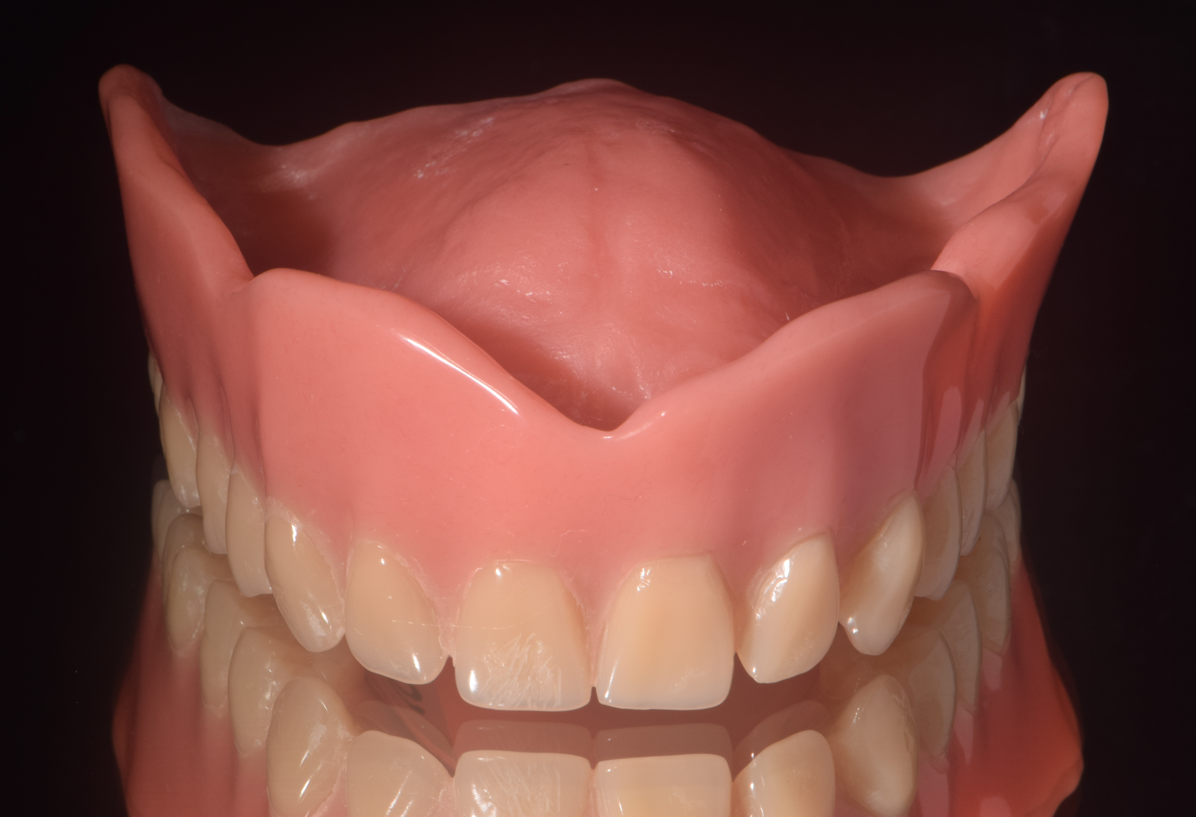 | 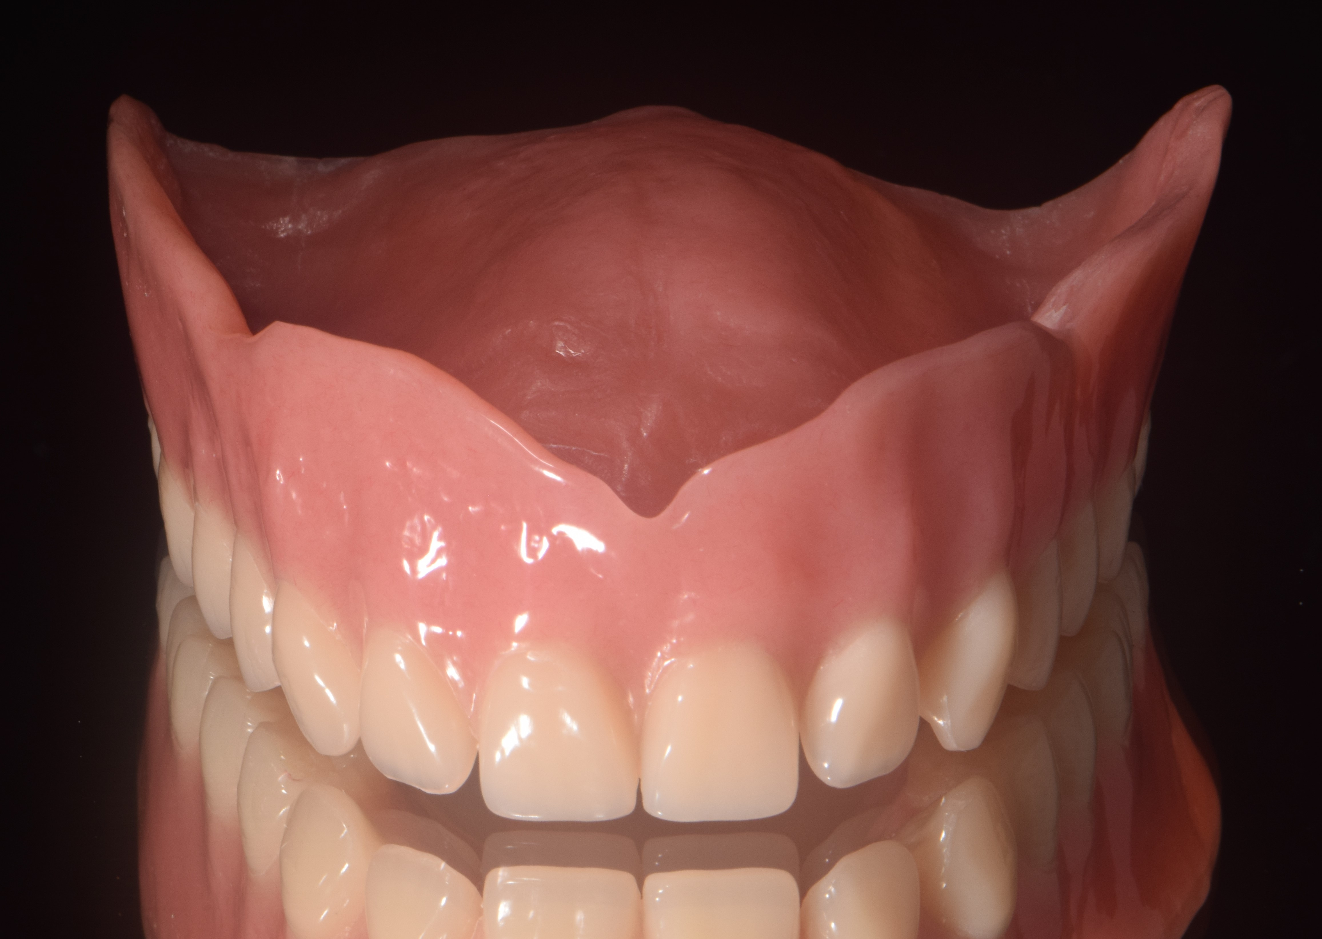 | 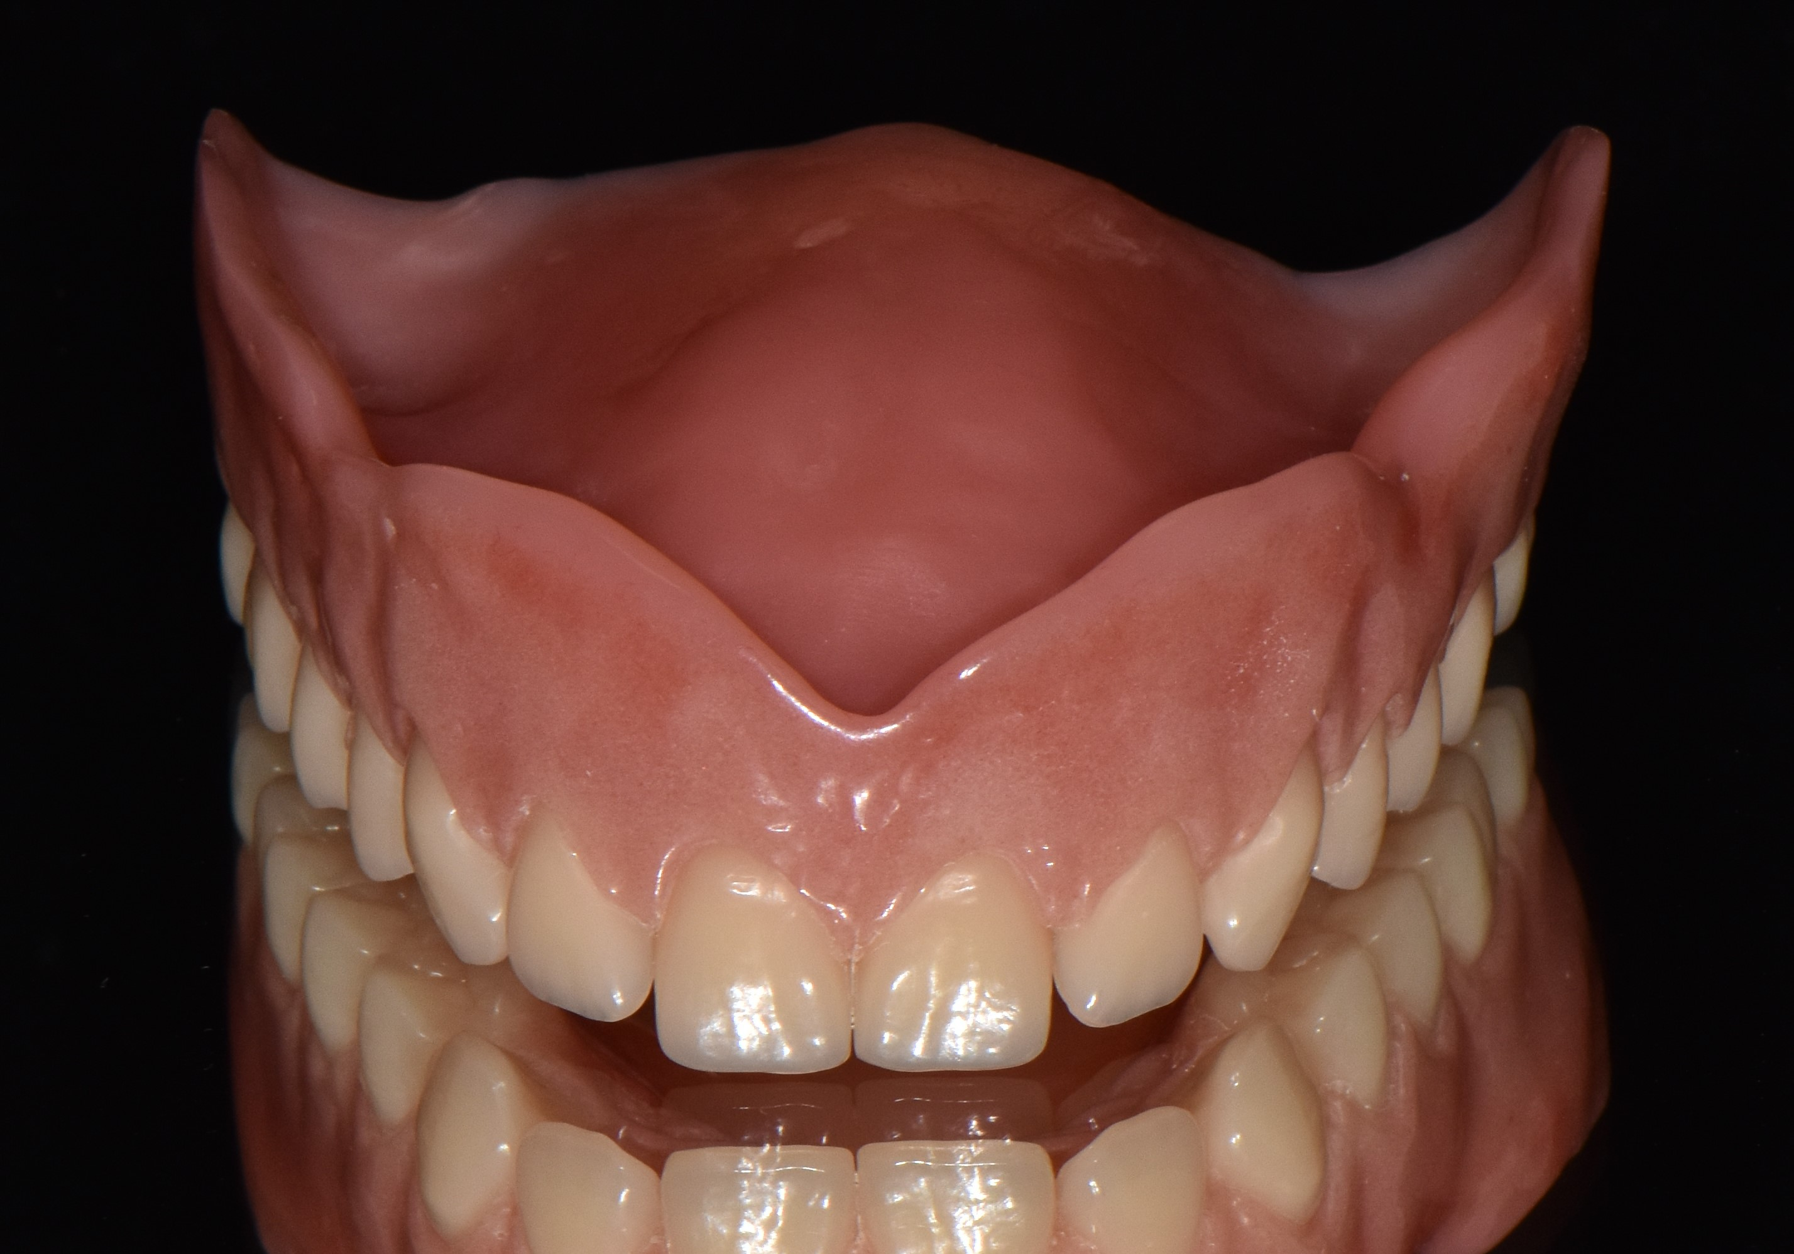
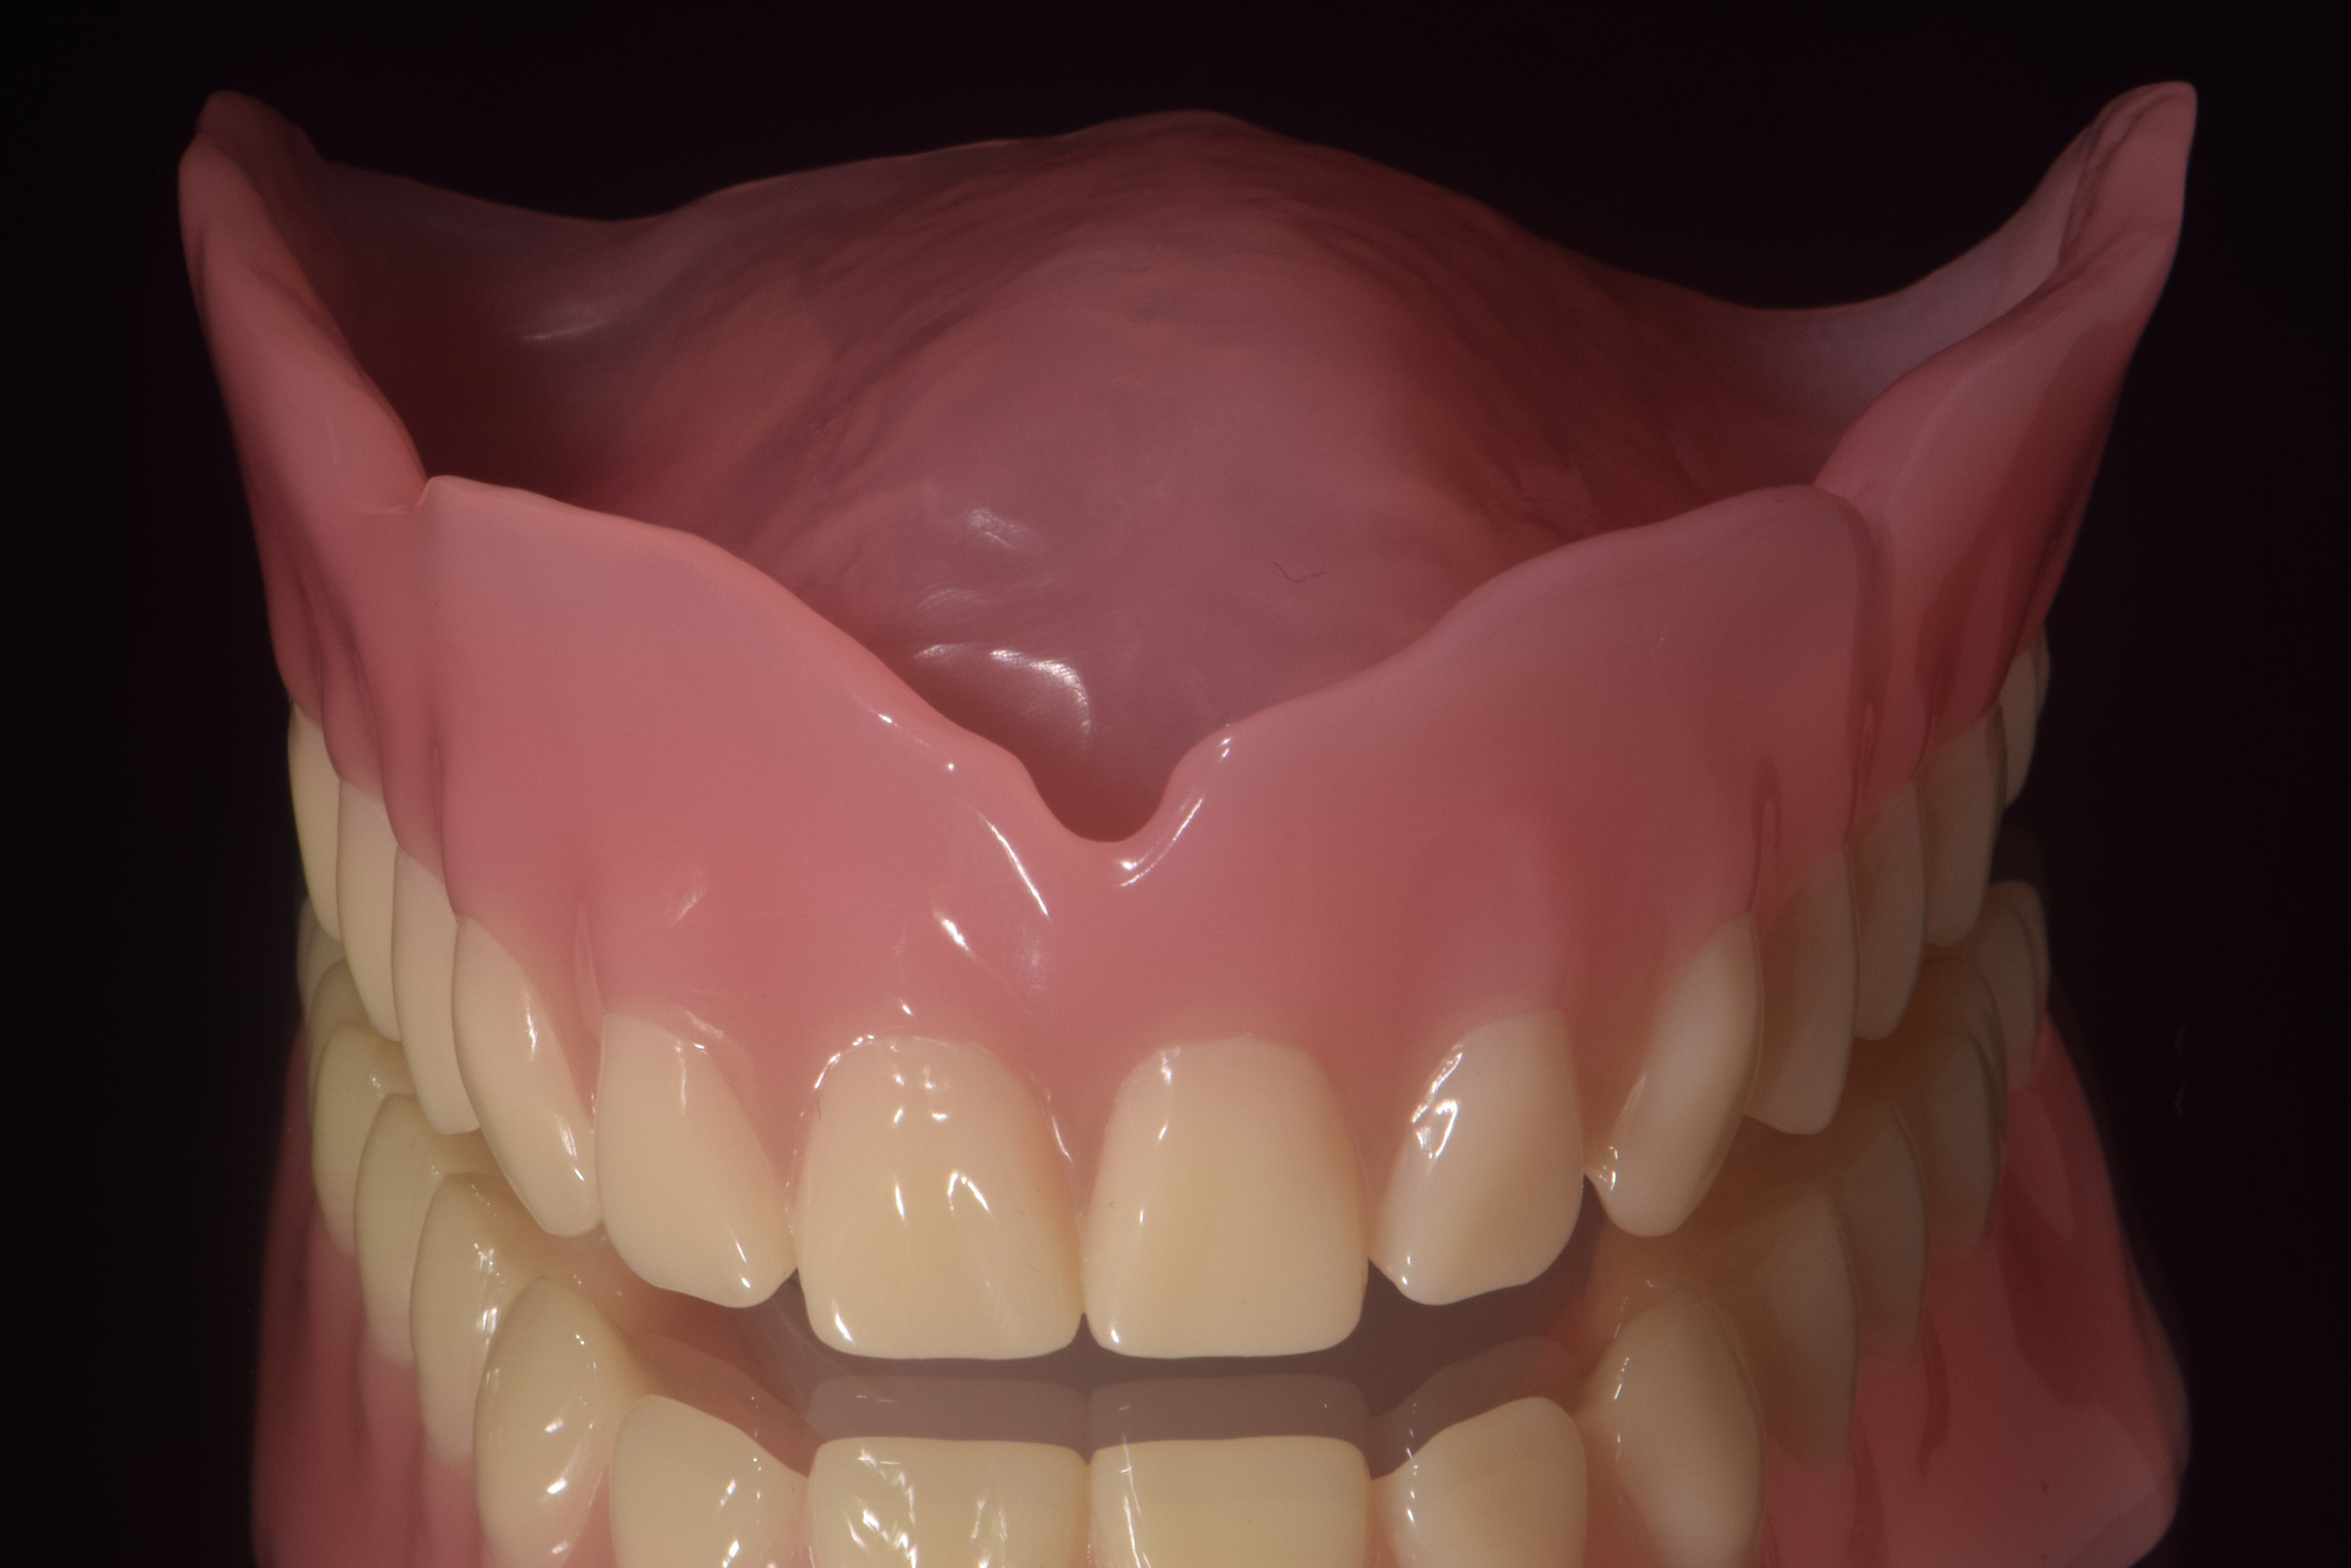 | 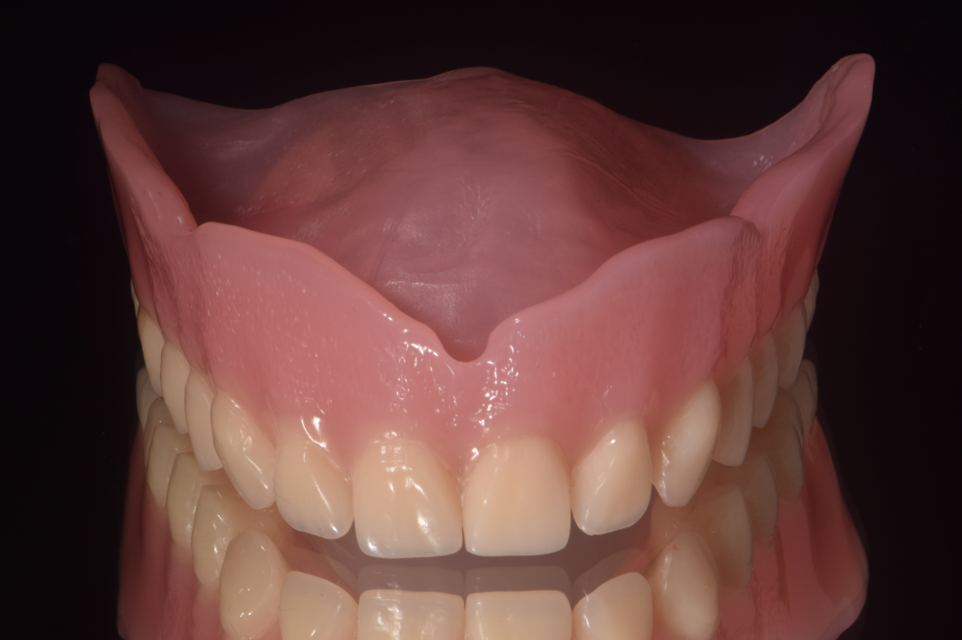 | 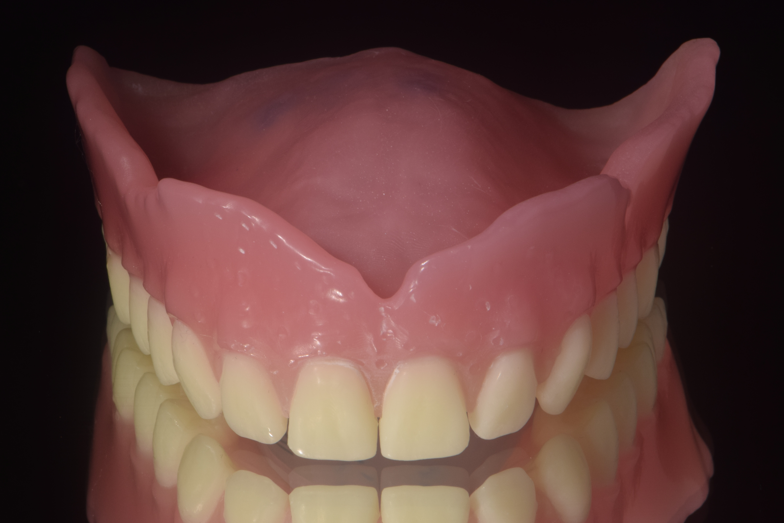
Fig 1A-F (from right to left). Examples of the specimens produced by the six different manufacturing methods: Conventional: A. Flask-pack-press (FP), B. Injection Molded (IM), C. Customized finish (NG) and CAD/CAM: D. Milled base with prefabricated, bonded teeth (M), E. fully milled (FM), F. Rapid-prototyping (P).

Fig 2. Overview of the 18 pairings with 15 = CRDP comparisons and 3 = mock trials

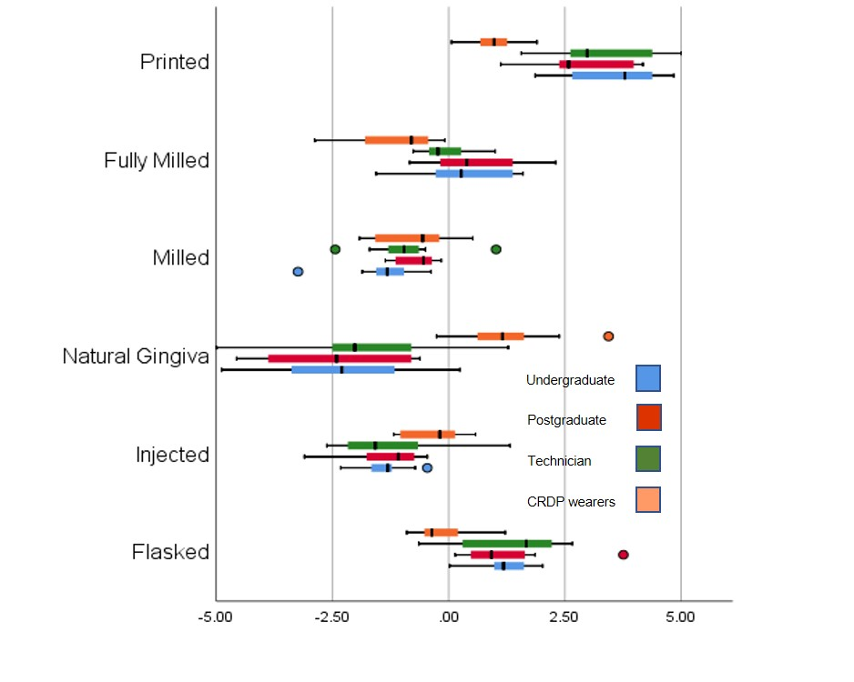
Figure 3: Box plot of global preference scores per participant group (-5 highest preference, 0 no preference, 5 lowest preference).
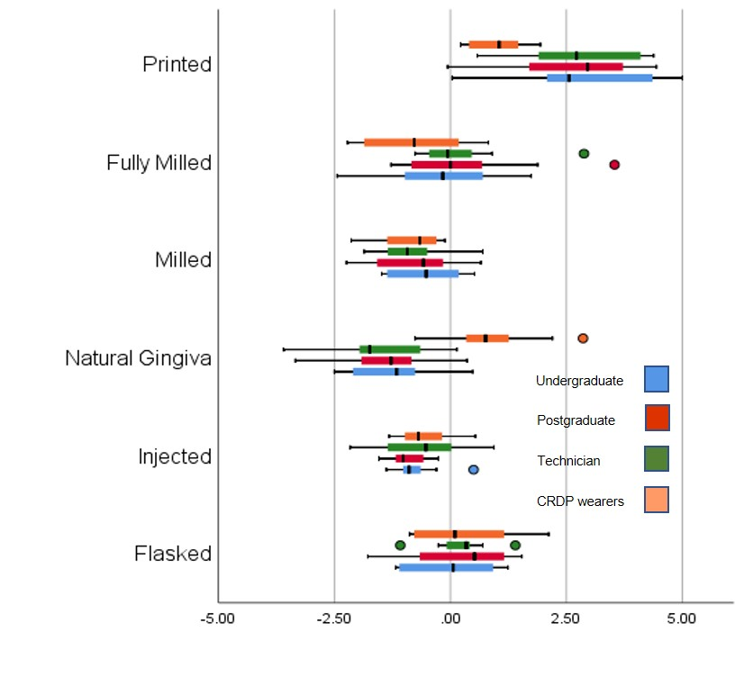
Fig 4. Box plot of white preference scores (Q1) per participant group.

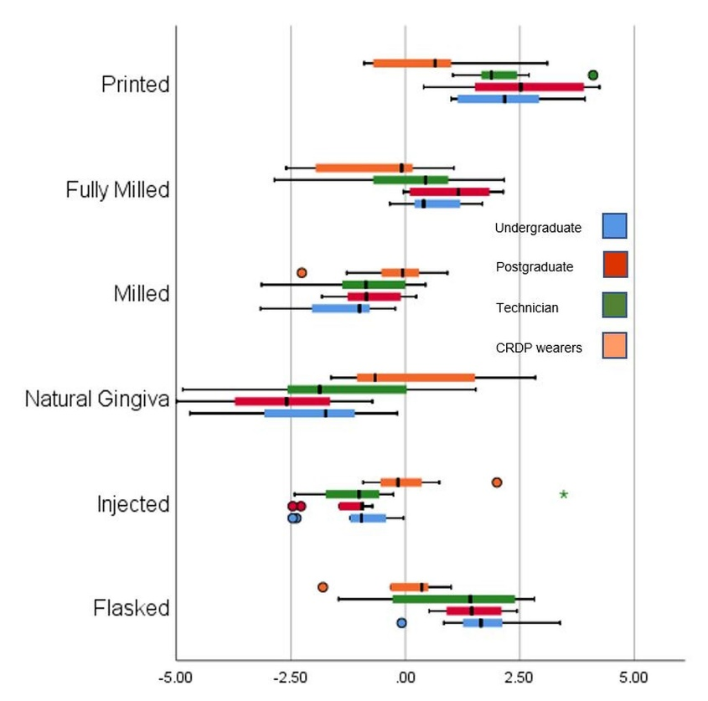
Fig 5. Box plot of pink preference scores (Q3) per participant group.
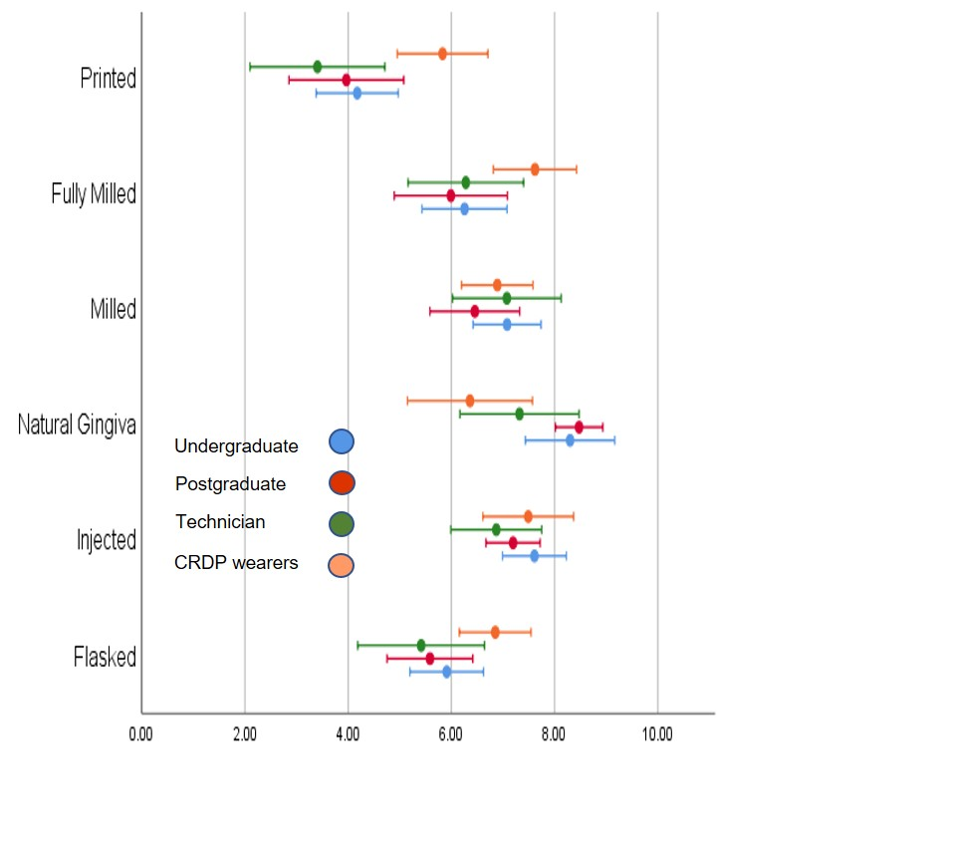
Fig 6. Overall ratings per CRDP type (mean Q1-Q10), per participant group

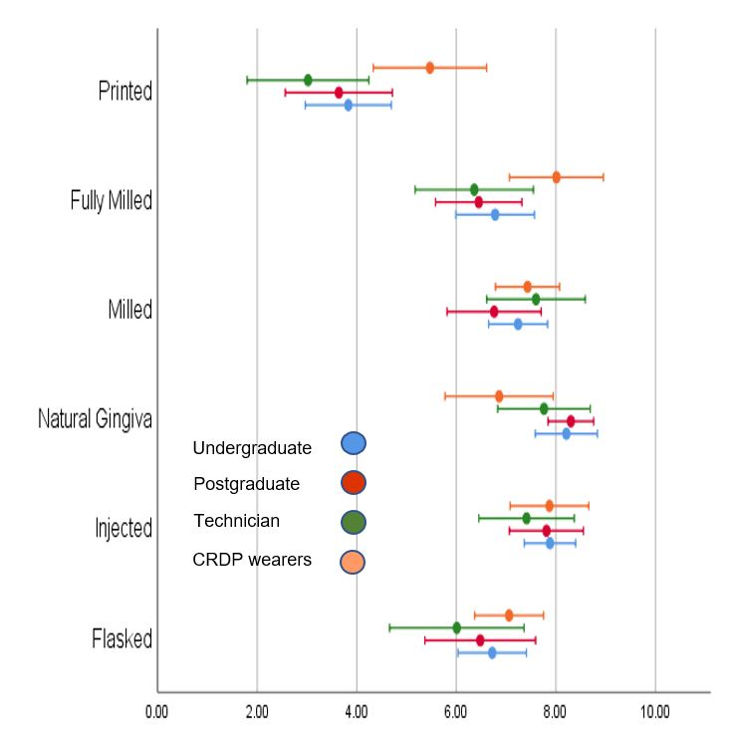
Fig 7. White rating scores (mean Q1-Q5) for CRDP group, per participant group
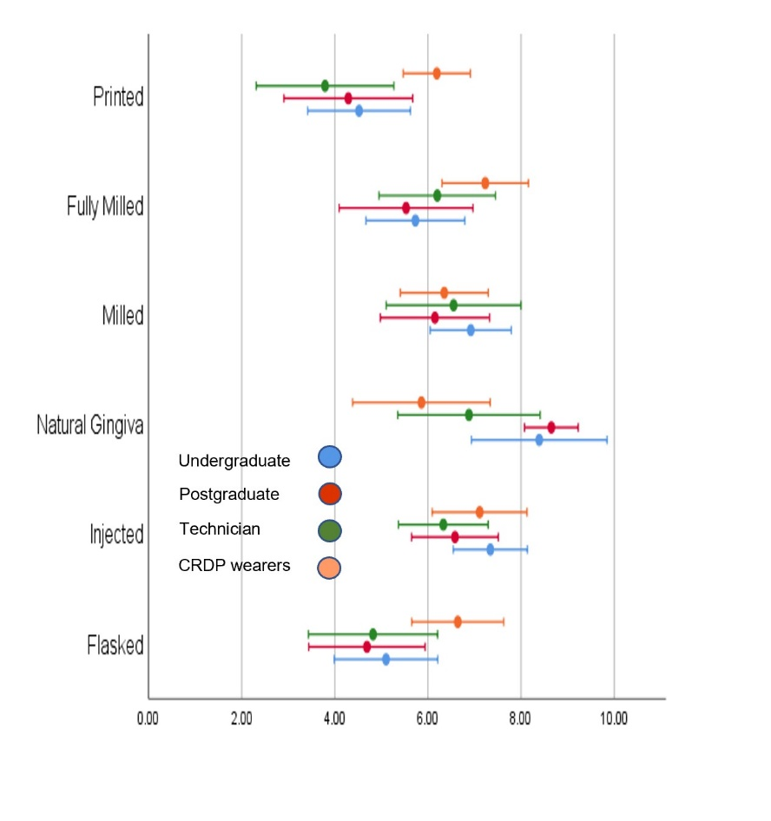
Fig 8. Pink rating scores (mean Q6-Q10) for CRDP group per participant group

DISCUSSION

Critique of study design
A particular feature of this study was the extraoral evaluation of the denture specimens. This choice of an extraoral setting came up as a specific point in the peer review of the original manuscript. It was the clinical relevance of assessing appearance of removable prostheses outside of the intraoral setting that was questioned. The advantages and disadvantages of the study design therefore warrants further discussion here.

Advantages of study design
The judging of denture specimens away from a clinical context allowed their general aspects to be standardized and the differences to be limited to the variations in esthetics parameters dictated by the six different manufacturing techniques and choice of tooth shade.
The study design also allowed the dentures to be handled and inspected directly by the participants. This direct and close evaluation is an inevitable and clinically relevant part of the professional process of providing CRDPs.
Handling and inspection are also part of daily use for denture wearers as they insert, remove and clean their removable prosthesis [1,2]. From first-hand clinical experience over three decades of working with removable prostheses, it is important that the CRDP is perceived positively in the hand of the wearer as well as in the mouth. The lower scores and ratings by the CRDP wearers of both the customized finish with a multi-coloured nature mimicking gingiva and the rapid-prototyped dentures in this extraoral evaluation was therefore a very interesting and clinically relevant finding.
These two denture types clearly represented the opposite ends of the esthetic range amongst the six specimens. The CRDP wearers’ reaction could be explained by apprehension of loss of denture privacy [3] as a result of a conflict between too much versus too little dental reality [4]. A free comment offered by a CRDP wearer ‘that natural is not necessarily beautiful’ would seem to support this. An important conclusion from the study was therefore that it cannot be assumed that CRDP wearers will appreciate the esthetic craftsmanship and natural appearance of customized dentures or that they will accept the lack of detail currently offered in rapid-prototyped manufactured dentures.
A repeat observation from first-hand encounter of customized dentures in clinical practice, has been a wide range of variation in the finish between dental technicians. It has been a common finding that the customization has been exaggerated rather than being in keeping with the subtle reality of natural teeth and their surrounding gingival tissues. As the degree customization of the NG specimens in this study was at the lesser and more discreet end of the clinically observed range of variations [5], there is therefore even more reason to advocate caution and a share, informed approach to denture esthetics decision making.
Clinical experience has also shown that it is important that the esthetic finish of the denture does not increase the risk of food retention and stains or poses added difficulties in terms of cleaning. The latter is particularly important for the elderly patient where reduced dexterity makes removal debris and biofilm more of a challenge [6]. Direct evaluation of variations in not only denture appearance but also their surface contours and finish are therefore highly relevant to the CRDP wearer.

Disadvantages of study design
The study design limited to extraoral evaluation precluded opportunity for assessing the six different denture appearances in situ intra-orally. Similarly, no clinical information or context was offered in terms of the treatment indication or esthetic preferences of the potential CRDP recipient. Both points could be seen as a disadvantage and weakness of this study.
In defence of the potential weakness of not observing the dentures in situ intraorally, it could be argued that the two participating clinician groups and CRDP wearers were used to extrapolating from the extraoral to the intraoral context. The participating dental technicians were all based in dental laboratories and would by default be used to mainly assessing the denture appearance in an extraoral setting.
This extrapolation argument was further supported by a clear indication in that the participants focus of appreciation was on the appearance of the teeth, the part of the dentures known to be visible. Thus, the appreciation of white esthetics followed the global scores and ratings closely across all four participants groups. Of particular interest was the finding that the participants’ opinion of denture teeth known to be identical could be both positively and negatively influenced by variations in the pink esthetics that was either perceived to enhance or detract from their appearance.
Nevertheless, with the increased emphasis on patient centred care [7] and shared decision making [8], the relevance of including a patient context when exploring evaluation of denture appearance further is obvious.

Suggestions for further exploration of denture esthetics
A direct follow up to the present study could be to ask study participants to match the denture esthetic options to different clinical scenarios. These scenarios could offer specific patient information, esthetic desires as well as a pictorial context. The latter could demonstrate, for example, variations in gender and age and level of smile line. They could also offer more information on each of the denture types including cost and expediency of manufacture.
It would be interesting to explore whether the CRDP denture wearers would match the dentures with customized finish with a multi-colored nature mimicking gingiva to a desire for a more natural appearance. Equally, a clinical scenario indicating a need for an immediate, short-term replacement of a lost denture for short term use might demonstrate acceptance of the esthetic shortcomings of the rapid-prototyped.
Direct evaluation of the appearance of removable denture in situ in the intraoral setting would be desirable [9]. Replication of evaluation and comparison of several different dentures would, however, present a logistic challenge in terms of its execution. An indirect approach where images were recorded of the six different dentures in situ would be more manageable, not least from the denture wearer study subject’s perspective.
The images could include both still photos and video [5]. These could feature the dentures close up in the context of the mouth as well as at social distance. A further option would be to demonstrate the dentures in action during smiling, laughing and speaking. Social distance could be defined as a standard passport field of view. This would strike the natural balance of the context of the full face and the oral appearance on view in normal social interaction.
Selection of a representative patient or patients would require careful thought. To mimic the opportunity for evaluation of both the white and pink esthetics in this extraoral study, it would be natural to include a patient whose correctly restored physiognomy and smile line would allow display of both the denture teeth and some of the gingival aspects. As suggested earlier, other parameters could be age, gender as well as the incisal relationship of the selected patients and a natural corresponding customization of tooth arrangement.
If the six denture types had been assessed in an intra-oral setting and based on the findings in the present study, it is hypothesized that the participants might have been able to identify the NG denture customized finish with a multi-colored nature mimicking gingiva and the P rapid prototyped manufactured denture.
They would have been more likely to struggle with telling apart the other four dentures manufactured by conventional and subtractive milling techniques. It is very promising for the future of CAD-CAM and the manufacturing and clinical advantages that they will offer, that the professional groups and the CRDP wearers would have agreed that these four conventional and milled dentures observed in vivo provided a similarly unremarkable and acceptable appearance.

REFERENCES
[1] K.M. Neppelenbroek, The importance of daily removal of the denture biofilm for oral and systemic diseases prevention. J Appl Oral Sci. 23(6) (2015) 547–548.
[2] Denture Cleaning. Oral Health Foundation.
Denture cleaning | Oral Health Foundation (dentalhealth.org)
[3] J. Besford, F. Müller, Totalprothesen, in: L. Hupfauf, R. Nolden (Eds.), Ästhetik in der Zahn-, Mund- und Kieferheilkunde. PdZ spezial, Urban & Schwarzenberg, Munich, 1995, pp. 315-40.
[4] J.N. Besford, A.F. Sutton, Aesthetic possibilities in removable prosthodontics. Part 1: the aesthetic spectrum from perfect to personal, Br Dent J 224(1) (2018) 15-19.
[5] J.N. Besford, A.F. Sutton, Aesthetic possibilities in removable prosthodontics. Part 3: Photometric tooth selection, tooth setting, try-in, fitting, reviewing and trouble-shooting, Br Dent J 224(1) (2018) 15-19.
[6] A.S. Takamiya, D.R. Monteiro, V.A.R. Barão, A.C. Pero, M.A. Compagnoni, D.B. Barbosa, Complete denture hygiene and nocturnal wearing habits among patients attending the Prosthodontic Department in a Dental University in Brazil. Gerodontology 28(2) (2011) 91-6.
[7] L. Hallo, A. Gorod, S. Merchant, The evolution of healthcare towards patient-centred care and the need for systemic approaches. Systems Research & Behavioral Science 38 (2021) 191-196.
[8] N. Kasabreh, N. Dyer, J. C. W. Wang Shared Decision-Making in Evidence-Based Dentistry. Decisions in Dentistry 6 (2020).
[9] J.N. Besford, A.F. Sutton, Aesthetic possibilities in removable prosthodontics. Part 2: start with the face not the teeth when rehearsing lip support and tooth positions. Br Dent J 224(3) (2018) 141-48.

ORIGINAL ARTICLE PUBLISHED IN JOURNAL OF DENTISTRY

